Franklin Collinear Antenna 2 Levels Different Sides using Array Method 4 Stacking Units 360ᵒ with Integrated Reflector and Power Combiner for ADS-B S-Receiver Mode
Yussi Perdana Saputera^{a, b, *}, Topik Teguh Estu^{b, c}, Teguh Praludi^{c}, Ganis Sanhajiª
ªFakultas Teknik, Prodi Elektro, Universitas Islam Nusantara
Jalan Sukarno Hatta, No5301, Bandung, Indonesia
^{b}Radar Telekomunikasi Indonesia (RTI)
Jalan Mandolin No. 7, Turangga, Lengkong, Bandung, Indonesia
^{c}Pusat Penelitian Elektronika dan Telekomunikasi-LIPI (PPET)
Kampus LIPI, Jl. Sangkuriang Gedung 20, Lantai 4, Cisitu, Bandung, Indonesia

Abstract
In this study, an antenna system that could cover the 360ᵒ detection area using the microstrip method was created. The antenna design proposed uses the franklin collinear method with the addition of an array of arms to the left and right of the antenna and the addition of reflectors as a gain enhancer. The four antenna array units are combined using a power divider (combiner) as a unifying antenna. Antenna design with end fire radiation pattern cannot be used in receiving the ADS-B antenna system, because it works only in certain sectors with certain beamwidth, so it needs to be modified by adding an array of 4 units that make up 360◦ radiation of directional diagrams. The addition of the reflector is done by testing the optimum width. The most optimum width is obtained by the width of the side addition on the side of the antenna aperture cross section width of 80 mm. Based on the results of experiments that have been carried out for the design of receiver antennas for ADS-B applications that are required in the form of a radiation pattern in all directions using the reflector technique, the most appropriate gain increase is to use a phase difference for the antennas that are closest both left and right by 90º in ¼ λ conditions in the integration process using a 4 way power combiner. Response return loss at frequency 1.0752 GHz and 1.109 GHz is -15 dB, it means antenna has 33.8 MHz bandwidth with maximum response return loss at -23.22 dB and gain of 7.586 dBi, this antenna design is very suitable for use in the ADS-B application. Design and simulation at this antenna used CST software.

Keywords: ADS-B, antenna, microstrip, array, franklin, collinear, power combiner, reflector.

Introduction
Automatic Dependent Surveillance - Broadcast (ADS-B) is one of the important technologies in aviation, namely the technology for receiving information from aircraft. ADS-B technology is included in the S-Mode reception group which has the code number 17 [1]-[2]. In this research, Arhanud TNI - AD collaborated with PT. Radar Telekomunikasi Indonesia has developed a radar-based Surveillance Technology, IFF, and Mode-S receiver. The system is designed to be able to detect aircrafts, both civilian and military. For Mode-S reception, civil aircraft works at a frequency of 1090 MHz. The Mode-S reception works by using an antenna system that works 360ᵒ with a minimum gain of 3 dB, and a working frequency of 15 MHz. In receiving Mode-S, there are three links that can be used as a physical layer, namely 1090 MHz Mode-S Extended Squitter (1090 MHz ES), Universal Access Transceiver (UAT) and VHL Data Link (VDL) Mode 4. In receiving Mode-S, there are three links that can be used as a physical layer, namely 1090 MHz Mode-S Extended Squitter (1090 MHz ES), Universal Access Transceiver (UAT), and VHL Data Link (VDL) Mode 4. ADS-B is a system that uses 1090 MHz ES as the data delivery protocol. Examined from the name of the ADS-B, this is also meant as a broadcast system automatic surveillance and dependent. The automatic aspect of this system includes no requirement for interrogation to initiate data or squitter from the transponder, while the dependent element comes from the data dependency on the navigation system and aircraft capabilities.
* Corresponding Author.
Email: yussips@uninus.ac.id
Received: May 27, 2021 ; Revised: August 03, 2021
Accepted: December 01, 2021 ; Published: December 31, 2021

Open access under CC-BY-NC-SA
© 2021 PPET - LIPI
25-32

In this research, an antenna system that can cover a detection area of 360ᵒ using the microstrip method is created. The design of the antenna uses Franklin collinear antenna by adding arms to the right and left of the reflector for increasing of gain. Four antenna arrays are combined using a power divider (combiner) to antenna units.

Background

ADS-B Overview
ADS-B is located on an aircraft using an on-board navigation system to obtain information. Every 1 second, the aircraft broadcasts position, altitude, and other data to the nearest aircraft equipped with ADS-B technology and to earth stations, airports. Antennas on satellites are useful for locating aircraft and knowing the position of the aircraft. After the position of the aircraft has been obtained, the transponder provides an information signal to the ground station. After the data is received by the ground station, the data is processed and broadcast [3]. In the Regulation of the Director General of Civil Aviation number KP 103 of 2015 concerning Technical Standards for Aviation Telecommunication Facilities, there are ADS-B technical specifications. The technical specifications on the ADS-B are given in Table 1.

Antenna
An antenna is a device to transmit and/or receive electromagnetic waves. Electromagnetic waves are often referred to as radio waves. In order to be received properly by the receiver, it is necessary to pay attention to the parameters that are the basis of the antenna such as gain, radiation pattern, polarization, and directivity [4]. In order to be received properly by the receiver, it is necessary to pay attention to the parameters that are the basis of the antenna such as gain, radiation pattern, polarization, return loss, VSWR and directivity [4]. In the wireless communication systems, antennas do not need cable for a connection between transmitter and receiver. It is to radiate and receive electromagnetic waves. Antenna is transitional device between transmission lines and free space. Because it is a transitional device between the cable and free space, the antenna must have properties in accordance with the cable media feeder.

Table 1.
ADB Technical Specification Regulations and Standards, Directorate General of Civil Aviation
No. | ADS-B Technical Specifications | Information
1. | Detection Range | 250 NM at 290 FL
2. | Target Capacity | ± 250 aircraft targets at the same time
3. | Process capability | DO 260, DO260A, DO260B
4. | Update rate | 1 second<rate <5 seconds as operationally required
5. | Target Type | Mode ES, Mode A/C, Mode S
6. | Time Synchronization | GPS Network Time Server
7. | Receiving signal | Extended Squitter ADS-B, Mode S 1090 MHz, GPS.
8. | Network Latency | 95% <2 seconds of G/S output
9. | Reliability 1 | 2 autonomous groundstation including antenna, each providing data, no common point of failure
10. | Reliability 2 - MTBF | Each groundstation including antenna to have MTBF> 10.000 hrs
11. | Communication link | Completely duplicated, no common point of failure.
12. | Availability | 99,999 %
13. | Integrity - Groundstation | Site Monitor, GPS RAIM, monitored item by RCMS, at least:  Status Reporting; Buffer Overflows; Processor Overloads; Target Overloads;
14. | Integrity - Data communication And Processing | All system up to ATM system errors < lxlOE-6
15. | Data Transmission Mode | Asterix Category 21 edition: 0.23, 0.26, 1.6, 2.1 or latest edition
16. | Grounding system | PUIL2000 standard
17. | Recording dan playback | 30 days
18. | Backup power supply | Redundant UPS with 5 hours

The radiation field of a radiating antenna is characterized by the Poynting complex vector E x H where E is the electric field vector and H is the magnetic field vector. The closer to the antenna, the imaginary (reactive) and (E, H) pointing vector decreases much more drastically with respect to 1 / r, meanwhile when the pointing vector is real (radiating) and (E, H) decreases in proportion to 1 / r which means the antenna beam is reduced [5].

Microstrip Antenna
In this research, microstrip antenna is used because it can work at a very high frequency as it is required in our research, and it is in the form of a thin board that makes it easy to fabricate. Microstrip antenna is made using a substrate to make the patch of antenna for radiation [6]-[7], at the top layer of the substrate, this layer is usually made of conductors. Conductors are generally made of copper, aluminum, or gold. In this layer, it will be formed into a certain shape to get a radiation pattern as desired. Dielectric, the middle part of the substrate, is used in this layer dielectric material. A dielectric with a thickness h has a relative permittivity (ε_{r}) in the range of 2.2 to 10. The dielectric constant is kept low to increase the overflow field which is useful in radiation. The lowest layer of the substrate is called the ground plane, which has a simple geometric shape, for example a circle, rectangle, triangle or other shape that functions as a reflector to reflect unwanted signals [8]-[9].

Power Combiner
Power combiners/dividers are used to combine the power of multiple transistors in an amplifier or antennas in a system or divide the power among channels in a receiver. The Wilkinson power combiner/divider is used to collect power from multiple sources, or to distribute it to arrays of transmitters, sensors, etc. In the conventional Wilkinson power combiner/divider, all the ports are matched to the same characteristic impedance, typically for Z₀ = 50 Ohm.
Microwave power divider (combiner), such as the Wilkinson divider can be realized in microstrip or strip line technology, generally using the ¼ λ transformation, where this transformation is used to convert the input impedance, which is generally 50 ohms to the output impedance represented by a parallel combination of multiple outputs. The type of microwave power divider (combiner) accomplished in this study has 2 input / output inputs and 1 input / output, with a value of s₁₂, which has the same characteristics as the s-parameter in s₂₁, s₃₁ [10]-[12].

SYSTEM DESIGN
The antenna was designed using an array system in a 360 ᵒ array using the antenna array method. The antenna we had designed was an antenna with the franklin collinear type applied to the microstrip material used, which is adapted from the dipole antenna, by irradiating using a long field, with a length of (1 / 2) λ. The franklin antenna is commonly used for radio communications, such as HF and VHF and is made of metal wires and pipes. In this study, the length of the antenna is multiplied with the aim of seeing the maximum gain results from the antenna design that will be used. In this research, the microstrip antenna will be fed with the microstrip line feed feeding technique. Coaxial feed or probe feed is a technique that is carried out by connecting the inner conductor of the coaxial cable connected to the radiating conductor and the outer conductor of the coaxial cable connected to the ground, using a female SMA connector. The advantage of this feeder is that it can be placed at any location in the radiation area or the desired transmission line to obtain impedance matching from the antenna. The antenna is integrated using a FR4 reflector and integrated using a 4-way Wilkinson power divider.
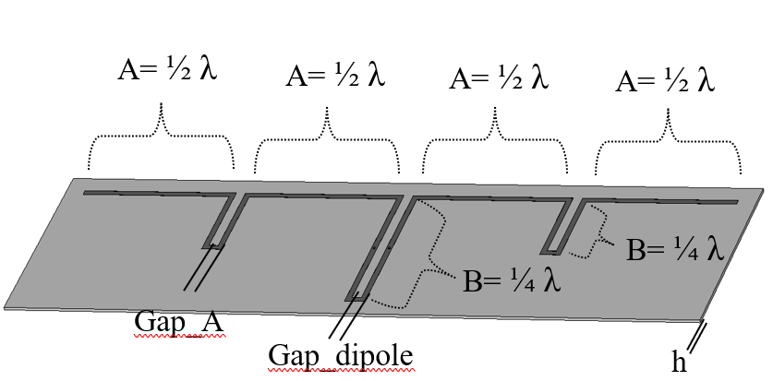

Figure 2. Initial Franklin Colinear Design on Microstrip.
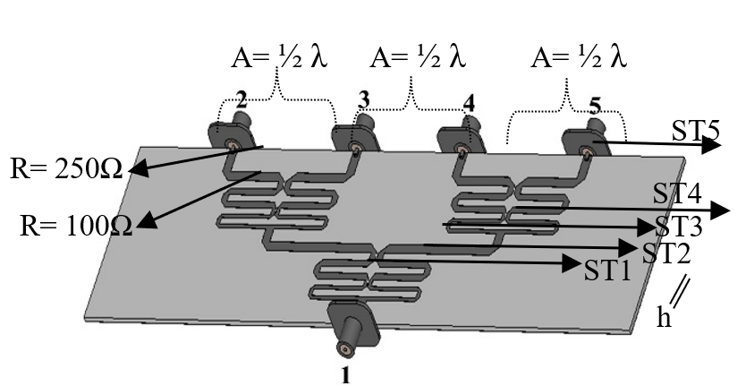
Figure 3. Initial Design of Power Combiner on Microstrip [7].
Design, simulation, and realization for this antenna is using FR4 substrate, with the parameters of substrate are ε_{r} = 4.4, h = 1.6 mm, then the value of λ based on the calculation results is 131.21 mm. The length (1/2) λ of the antenna is arm A with 65.605 mm and (1/4) λ is arm B at 32.8 mm and a width of 3.05 mm. Figure 1 is the overall design of the ADS-B antenna system proposed, using 4 franklin collinear array antennas. The antenna is integrated using a 4-way power combiner and attached to the insides of the ADS-B system. For the antenna system design, it can be seen in Figure 2. Figure 3 is the design of the 4-way power combiner. The 4-way power combiner used the Wilkinson method, where this method uses a resistor to increase the isolation value between the branch ports.
The stages in designing a 4-way power combiner are to do a 2-way design first, then combine it into 4 ways with the same structure as 2-way, but there is a multilevel process as can be seen in Figure 3. In the 4- way power combiner integration, the resistor placed on each transmission line has 2 stages. The first stage is 100 Ω, obtained from the sum of the impedance of the radio frequency (RF) transmission line, which is 50 Ω. For the value of the second stage resistor, that is, at least increasing 2 times from the first resistor, in this case the value of the second stage resistor becomes 250 Ω. ST₁ is a transmission line connected directly to a connector with an impedance of 50 Ω. For ST₂, it is parallel to the source impedance. In theory, the value of ST₂ and ST₃ have the same value, that is 70.71 Ω, using a transformer, so that the cleaning is smoother. The purification process uses the impedance 59.5 Ω for the ST₃ value. For ST₄ and ST₅ values have the same value because they are the main transmission line, which is worth 50Ω. See detailed sizes in Table 2 and 3.
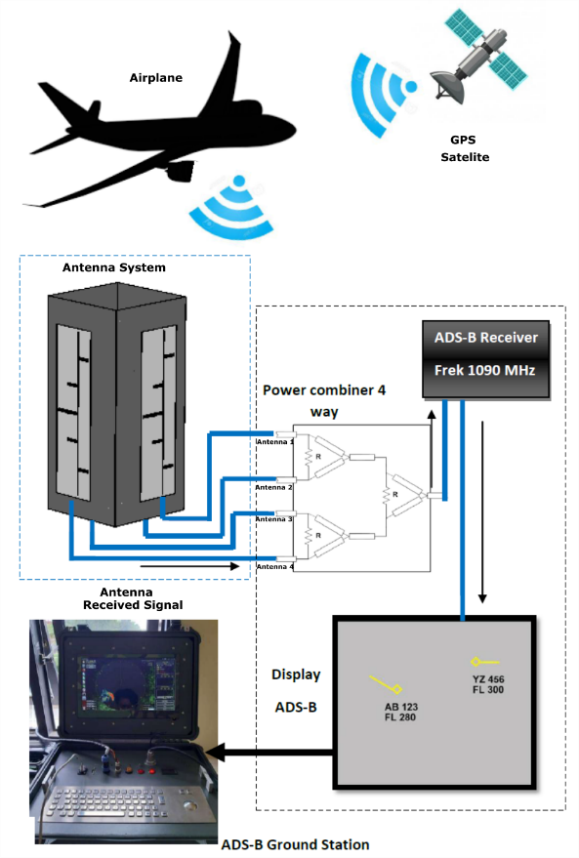

Figure 1. Antenna Design for ADS-B Receiver System.
The optimum simulation results of the return loss parameters are obtained with the franklin collinear antenna design of -24.36 dB. The bandwidth obtained from this design has a limit of -15 dB at 34.8 MHz, from a frequency of 1.07 GHz to 1.11 GHz, which is in accordance with the specifications for ADS-B bandwidth requirements ranging from 15-30 MHz.

Table 2.
Value of Size from Antenna Calculation Results.
No. | Variable | Value
1. | A | 65.605 mm
2. | B | 32.8 mm
3. | Gap A | 3 mm
4. | Gap Dipole | 3 mm
5. | Substrate Distance | 10 mm
6. | h | 1,6 mm
7. | Copper | 0.035 mm
Table 3.
The Size Value of the Power Combiner Calculation Results.
No. | Variable | Value
1. | A, ST4_ Length | 65.60 mm
2. | ST1, ST4, ST5_ Width (50 Ω) | 3.05 mm
3. | ST1, ST5_ Length (50 Ω) | 38.39 mm
4. | ST2_ Width (70.71 Ω) | 1.59 mm
5. | Substrate Distance | 10 mm
6. | h | 1.6 mm
7. | Copper | 0.035 mm
In Figure 4, there is also a graph of the results of the optimization of the 4-way Wilkinson combiner, with the results of the return loss for each connector, for the port 1 arrangement red line, with the name return loss S₁₁. Port 1 is the result of the combination of the other 4 branch ports, which in other words, there is no isolation effect from the other ports. Port 1 produces a return loss value of -30.29 dB, with a bandwidth of 121.50 MHz, with a frequency limit 1.02 MHz to 1.14 MHz. For the branching port, the power obtained from port 2, port 3, port 4, and port 5 produces different return loss values, but is still within the limit range specification of the required value, which is below -15 dB. The difference that occurs is due to the influence of the position of the port distance placement, so that the length of the transmission line arm connected to each branch port produces a different length. Apart from the outcome of the transmission line, the effect that occurs is also due to the coupling effect between the connectors. The port 2 graphic with a green line in Figure 4 is called s₂₂ with a return loss value of -22.18 dB, for port 3 is -18.81 dB, Port 4 is -20.16 dB, and port 5 is -22.26 dB.
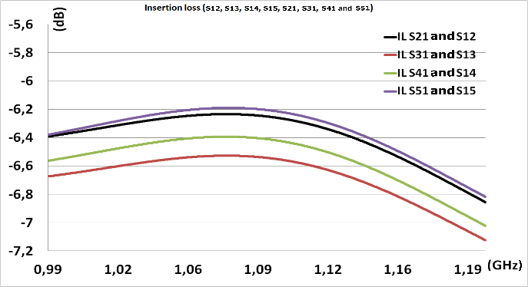
Figure 5. Simulation Result of Insertion Loss Optimum Combiner Wilkinson 4-Way Microstrip.
In the use of a power combiner using Wilkinson as a separator or combining power from the antenna, careful design and calculation is required regarding the loss that will occur when the power flows through each transmission line on the power combiner. The loss that occurs will result in the performance of a power combiner that can work optimally or even attenuation occurs when powering the amplitude of the signal passed, the loss parameter in the power combiner is called insertion loss. Figure 5 is a graph of the results of insertion loss obtained in the process of optimizing the dimensions of the power combiner. Theoretically, the insertion loss calculation is obtained by performing a logarithmic calculation of the number of branch ports to be designed. The calculation for the 4-way power combiner dB. In fact, with the use of a power combiner, the limit of the insertion loss value is 6.02 dB, which becomes the benchmark for the resulting loss limit. In Figure 5, there are 4 loss streams that can be observed, namely from port 1 to port 2 with the naming on the black graph S₁₂ and vice versa S₂₁ of -6.24 dB. The values of S₁₂ and S₂₁ mean that the loss occurs during the electromagnetic wave transfer is ~0.2 dB. In a radio frequency (RF) circuit, the loss process that occurs should be more than 3 dB, which means there will be a decrease or loss of ½ of the power in the amplitude of the signal that flows. In the results, the loss that occurs for S₁₂ and S₂₁ is still very far from 3 dB, which means it is very effective, which is able to pass nearly 98% power and likewise for insertion loss that occurs on port 1 to 3 and vice versa with a red graphic with S₁₃ and S₃₁ values of -6.54 dB, with a loss value of ~0.53 dB. For ports 1 to 4 and vice versa 4 to 1 of -6.40 dB, with a loss of ~0.40 dB. Finally, for ports 1 to 5 and 5 to 1 of -6.19, with a loss value of ~0.19 dB. Overall, the loss value obtained is far from 3 dB, with a maximum value of ~0.53. The difference in value at each port occurs at the difference in the distance at each port placement for the branch, and also, as already explained, on the effect of the length of the transmission line, especially at the end of the port that is connected to the arm at 2-way to 4-way branching.
One of the important parameters in a power combiner is the value of isolation or mutual coupling between branch ports and the resulting phase value between branch ports to and from a single port. The isolation graph obtained from the dimensional optimization process can be seen in Figure 6. The theoretical isolation value process in the antenna requirement circuit is -15 dB, where each antenna has a small effect on one another. In Figure 6, it can be seen that 2 to 3, vice versa, and port 4 to 5 and vice versa, produce different values with 2 to 4, 2 to 5, and 4 to 3. This is because the positions of ports 2 and 5 are at the end of the power combiner. Then the distance obtained is shorter than the distance between the ports in the middle position, and the ports at the end are affected by the transmission line in front of it, so the resulting isolation value is quite large. In addition, the effect of isolation is obtained from the use of the 100 Ω and 250 Ω resistors in the 4-way power combiner.
Figure 7 shows the results of the phases obtained during the process of streaming electromagnetic waves on each transmission line from a single port to each branch port. The difference in the obtained phase values must not be more than 5ᵒ, this is because, if there is a large enough phase difference, it will result in the phase of each port originating from the merging of the antenna experiencing a difference, so that it will influence the multiplication process diagram on the antenna and change the shape of the radiation pattern that occurs and affects the gain value obtained. Therefore, the phases obtained must be as much the same as possible, both from ports 1 to 2, 1 to 3, 1 to 4 and 1 to 5. For details on the parameters obtained in the combiner, you can see in Table 4.
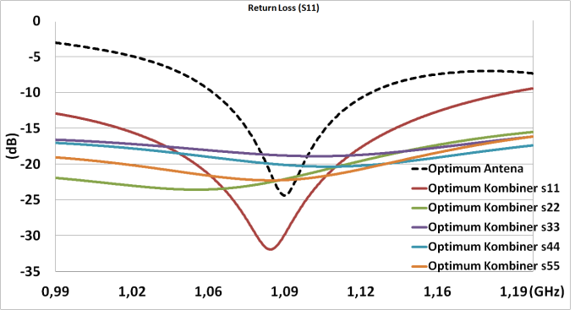
Figure 4. Simulation Results of Optimum Return Loss Antenna Franklin Collinear and Combiner Wilkinson 4 Way on Microstrip.
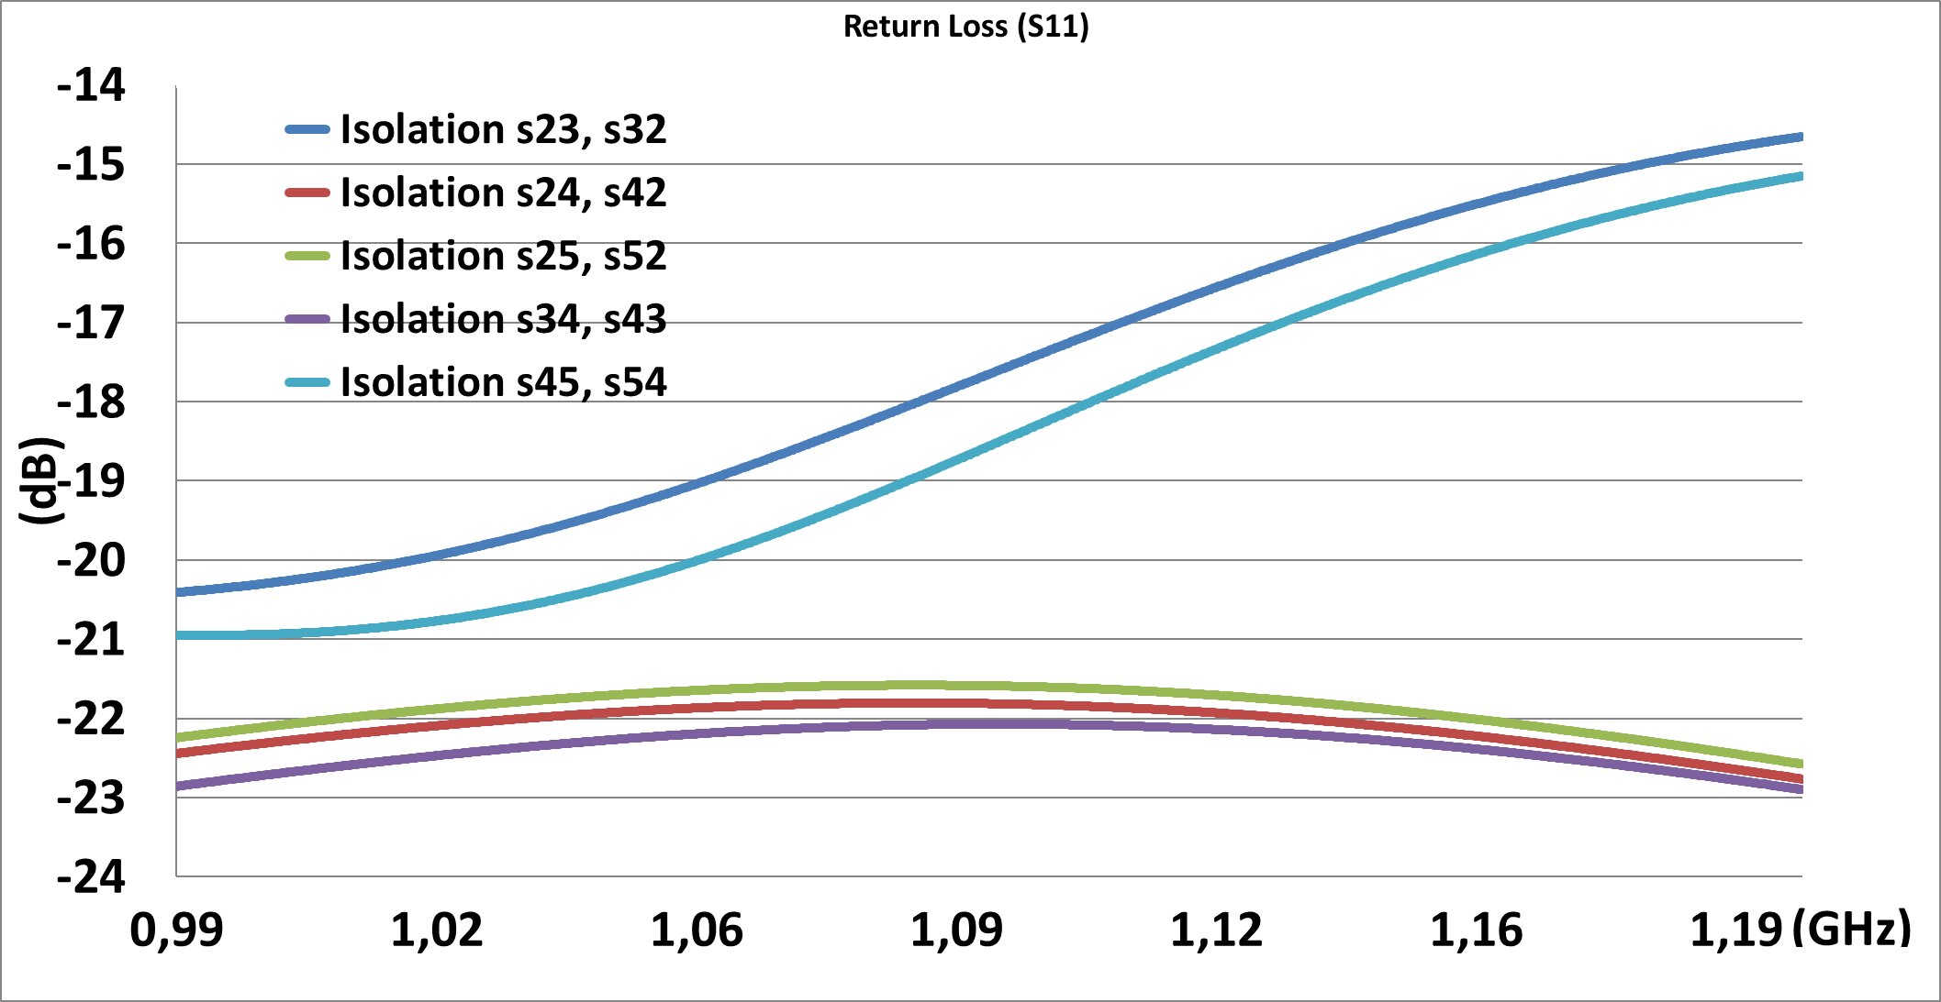
Figure 6. Simulation Result of 4-Way Wilkinson Combiner Isolation on Microstrip.
The next research process is to add 1 pair of arms A and B to see the increase that occurs in the Franklin Colinear antenna before adding a reflector. Arm enhancement is done by making a pair of arm A and arm B to the left and right of the antenna, which arm A is at the left of the antenna and arm B is at the right of antenna. The arrangement of arm B, which is carried out with different side directions, for the design that has been done, can be seen in Figure 8.
Table 4.
Power Combiner Parameters at 1,09 GHz.
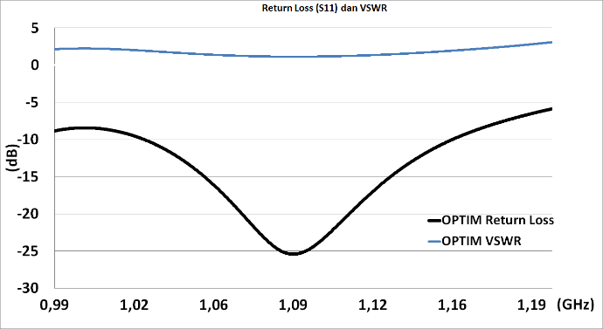
Figure 9. Franklin Collinear Optimum VSWR and Return Loss Value with Additional Arm.
No. | Parameter | Value
1. | VSWR Port 1 | 1.06
2. | VSWR Port 2 | 1.17
3. | VSWR Port 3 | 1.26
4. | VSWR Port 4 | 1.22
5. | VSWR Port 5 | 1.17
6. | Phasa s21/s12 | 151.9◦
7. | Phasa s31/s13 | 153.7◦
8. | Phasa s41/s14 | 159.9◦
9. | Phasa s51/s15 | 154.9◦
Figure 8. Design of Franklin Collinear Optimum Antenna with Additional Arm on Different Sides of Arm.
Table 5.
Results of Parameter Optimization of Franklin Collinear Antenna Dimensions.
No. | Parameter | Different side
1. | VSWR | 1.12
2. | Return Loss | -24.97 dB
3. | Impedance | 52.57 + J5.26Ω
4. | Bandwidth | 130.4 MHz
5. | Frequency Limit | 1.03GHz – 1,16. GHz
6. | Gain | 4.20 dBi
7. | 3 dB Angel (HPBW) | 28.2ᵒ
8. | Directivity | 5 dBi
The results of the return loss from the side difference antenna are -25.43 dB with a bandwidth of -15 dB return loss limit of 78.70 MHz. From a frequency of 1.05 GHz - 1.13 GHz, an antenna with an extra arm design produces a greater bandwidth than the original design antenna, this is in line with the theory that the sloping return loss, the greater the resulting bandwidth, and the sharper the return loss, the resulting bandwidth will be smaller. Graph of the return loss and VSWR response from the antenna can be seen in Figure 9.
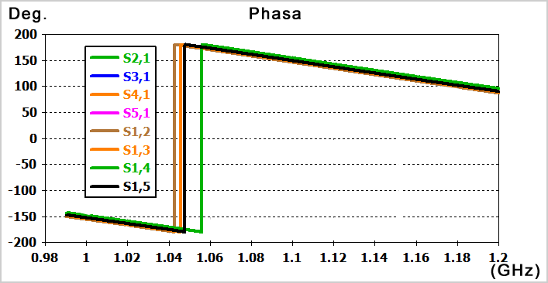
Figure 7. Simulation Result of the Wilkinson 4-Way Combiner Optimum Phase on Microstrip.
In order to increase the antenna gain, a reflector is added to one side of the antenna cross section. The reflector material used is FR 4 double layer copper, with h = 1.6 mm. The use of a reflector that is expected to increase the gain 2 times from an antenna without a reflector, in theory the addition of a reflector is like the principle of reflection, with an increase in the direction diagram on the side of the radiation surface adjacent to the reflector and changing the direction of the emissive axis, so that the opposite axis increases 2 times. However, the process of adding a reflector will change the type of directional diagram produced. In the initial antenna design, the resulting direction diagram or radiation pattern is omnidirectional, whereas when using a reflector, the resulting radiation pattern becomes unidirectional, or end fire radiation pattern, in other words the antenna with the maximum main emission in the direction parallel to the main plane where the antenna is located. An antenna design with an end fire radiation pattern cannot be used in the reception of the ADS-B antenna system because it works only in certain sectors with a certain beamwidth, so it is necessary to modify it by adding an array of 4 units which form 360◦ of radiation from the direction of the radiating diagram. The addition of a reflector is done by testing the optimum width, the most optimum width is obtained by adding the width of the side addition of the antenna aperture cross-sectional width of 80 mm. The geometry design of the antenna system design using the addition of a reflector can be seen in Figure 10. The optimization results of the franklin collinear antenna with the addition of an arm and a return loss reflector and VSWR are in Figure 11.
(a) (b)

Figure 13. Antenna Radiation Pattern (a). Without Reflector (b). With Reflector.
From the simulation results obtained, the VSWR value obtained in the optimization process at a frequency of 1.09 GHz is 1.185 dB shown in a red line in Figure 11. The return loss value of -21.43 dB is shown in a blue line. The bandwidth resulting at the range of frequency 1.076 – 1.107 GHz is 31 MHz, which is at the range of the ADS-B specifications. Antenna design using a reflector produces a very significant difference in the resulting gain and direction diagram. The gain of the antenna without reflector is 4.20 dBi with a directivity of 5 dBi. Antenna using an additional reflector produces a gain of 10 dBi, with a directivity of 11.55 dBi. From the result of dissimilarity in gain and directivity, it can be seen that the addition of a reflector gives an increase in gain and changes the shape of the radiation pattern. The difference in polarity can be seen in Figure 12. The graphic image from the results of the polar or 2-dimensional direction diagram shows a significant difference, that the antenna without a reflector shown at φ = 90˚ with a black graph is the result of omnidirectional radiation, with values on all theta axes having almost uniform values. In contrast to the blue graph which shows the radiation pattern towards a certain theta angle showing the reflection of the addition of a reflector. Similarly, for the diagram φ = 0˚, it shows different results for an antenna without a reflector and an antenna with a reflector. The shape of the 3-dimensional polarity produced by the Franklin Collinear Antenna using a reflector and without reflector can be observed in Figure 13.
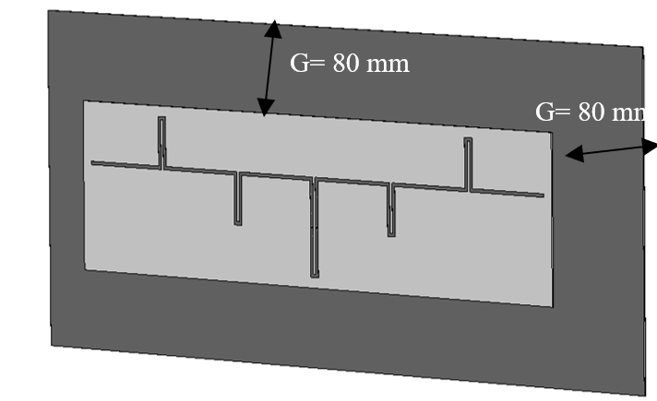
Figure 10. Franklin Collinear Geometry with Additional Arms and Reflectors.
Figure 14 is the final design of the Franklin Collinear Antenna design with the addition of an array and a reflector and is arranged in a square to get a 360ᵒ radiation pattern with integration using a 4-way power combiner. For Figure 15, the maximum return loss of the range of antenna bandwidth is -23.22 dB at frequency range of 1.07 GHz - 1.109 GHz and has return loss -15 dB at both frequency limits. The reflector is used to change the direction of the beamwidth, which initially leads to the 0-degree phi and theta planes from 1 degree to 360 degrees to 0 degrees phi and theta directions, or the direction of the main antenna cross-section, from omnidirectional to unidirectional. Furthermore, the addition of a reflector with the aim of increasing the gain, to see the difference in the shape of the radiation pattern can be seen in Figure 13.
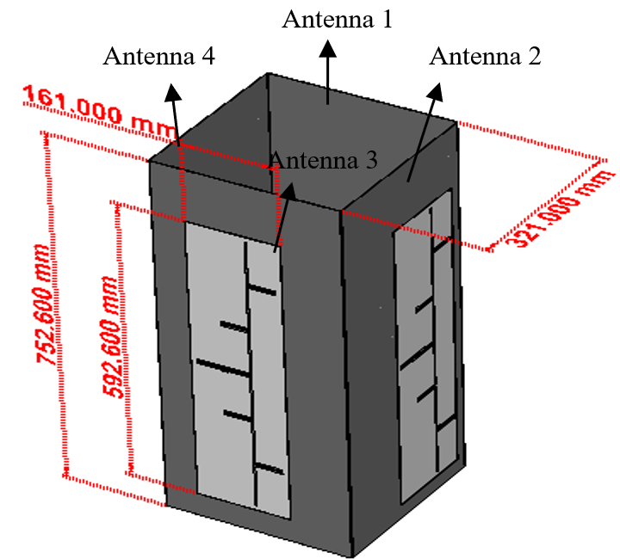
Figure 14. Antenna of ADS-B Receiver System Using Reflector with 4 Units Arrangement.
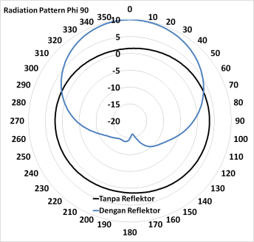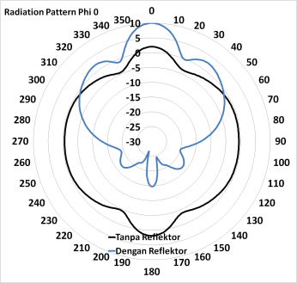
Figure 12. Antenna Radiation Pattern with and Without Reflectors a). φ = 90˚; b). φ = 0˚.
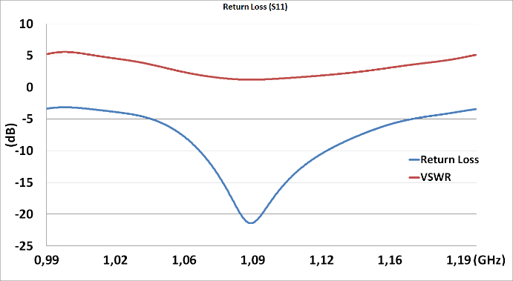
Figure 11. Franklin Collinear Optimum Simulation Results with Additional Arm and Reflectors.

Phase analysis 4 antenna
One of the important parameters in carrying out the integration of 4 antennas on a 4-way power combiner is the phase used in connecting, because the phase setting will greatly affect the process of multiplying the diagram between each antenna. By default, it is arranged with the same phase, or called uniform. However, with the same phase conditions and the conditions of contact radiation patterns, each other will cancel one another out, and the gain value decreases. The gain value is obtained when the phase is the same, in the conditions of S₁₁, S₂₂, S₃₃ and S₄₄ with a phase value of 0ᵒ of 6.34 dBi, for directivity of 7.9 dBi. Whereas for the 60ᵒ phase difference with the position of 2 different antenna phases that are directly connected, phase 0ᵒ antenna 4 and 2, 60ᵒ for 1 and 3 produces a gain of 7.23 dBi, with a directivity value of 8.8 dBi. Further testing by changing the phases 0ᵒ antenna 4 and 2.90ᵒ for antenna 1 and 3 produces a gain of 7.58 dBi, with a directivity value of 9.16 dBi. The 4th test changes the phase 0ᵒ of antenna 4 and 2, 150ᵒ for 1 and 3 resulting in a gain of 6.73 dBi, with a directivity value of 8.29 dBi. Next, the 0 phase of antenna 4 and 2.21ᵒ for 1 and 3 produces a gain of 6.74 dBi, with a directivity value of 8.31 dBi. And the last phase change test with the phase 0ᵒ antenna 4 and 2.24ᵒ for 1 and 3 produces a gain of 7.43 dBi, with a directivity value of 9.01 dBi. From the results of these phase differences, the most optimum difference is in the 90ᵒ phase, this is because the phase difference is equivalent to (¼) λ, which means that the value (¼)λ is the most effective transformer commonly used in radio frequency circuits, so it is suitable also to be adapted in the array of ADS-B signal receiving antenna systems. For a graph of the form of polarity generated from various experiments with different phases of each antenna, it can be seen in Figure 16. It will be different if the phase used is λ, which means that one position is in the line, then there will be no reduction from the multiplication of the diagram, but mutually reinforcing one another. If the differentiated phases are (½)λ then the positions in the same lambda (λ) are on parallel lines and will affect each other for the resulting direction diagram.
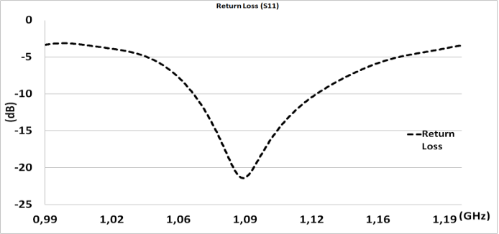
Figure 15. Franklin Collinear Optimum Return Loss Value for the Final Design.

Conclusion
Based on the results of experiments that have been carried out for the design of the receiving antenna of ADS-B applications which are required to be in the form of a radiation pattern in all directions using the reflector technique to increase the gain, the most appropriate is to use a phase difference for the antenna that is on the closest side both left and right of 90ᵒ or in conditions ¼ λ in the integration process using a 4 way power combiner. For a value of -23.22 dB with a bandwidth of -15 dB, the return loss limit is 33.8 MHz. From a frequency of 1.07 GHz - 1.11 GHz and a gain of 7.59 dBi, this antenna design is very suitable for use in these ADS-B applications.
(a) (b)

(c) (d)

(e) (f)
Figure 16. Simulation results of Phase Difference Antenna, (a) Same Phase 0, (b) Phase antenna 1 and 3 at 60ᵒ, Antenna 2 at 40ᵒ, (c) Phase Antenna 1 and 3 at 90ᵒ, Antenna 2 and 4 at 0ᵒ, (d) Phase Antenna 1 and 3 at 150⁰ and Antenna 2 and 4 at 0⁰, (e) Phase Antenna 1 and 3 at 210ᵒ, Antenna 2 and 4 at 0ᵒ, (f) Phase Antenna 1 and 3 at 240ᵒ,Antenna 2 and 4 at 0ᵒ.

Acknowledgment
Our gratitude goes to PT. Radar Telekomunikasi Indonesia and Arhanud TNI AD who have involved the author in research making Radar and ADS-B for Air aviation.

References

[1] E. A. Suteja, A. D. Prasetyo, B. Satriyotomo, D. H. Dafiq, and Edwar, “ADS-B microstrip antenna receiver design for CubeSat with SLOT,” in 2019 Int. Conf. Inf. Commun. Technol. ICOIACT, Yogyakarta, pp. 17–21, 2019.
[2] K. J. Matheou, R. D. Apaza, A. N. Downey, R. J. Kerczewski, and J. Wang, “ADS-B mixed SUAS and NAS system capacity analysis and DAA performance,” ICNS 2018 - Integr. Commun. Navig. Surveill. Conf., pp. 2B3-2B31, 2018.
[3] Y. Nurhayati and S. Susanti, “Implementasi Automatic Dependent Surveillance Broadcast (ADS-B) di Indonesia,” War. Ardhia, vol. 40, no. 3, pp. 147–162, 2014.
[4] L. Boccia and O. Breinbjerg, “Antenna Basics,” Sp. Antenna Handb., pp. 1–35, 2012.
[5] D. Bhalla and K. Bansal, “Design of a Rectangular Microstrip Patch Antenna Using Inset Feed Technique,” IOSR Journal of Electronics and Communication Engineering (IOSR-JECE), vol. 7, no. 4, pp. 8–13, 2013.
[6] K. F. Lee and K. F. Tong, “Microstrip Patch Antennas V Basic Characteristics and Some Recent Advances,” Proceedings of the IEEE, vol. 100, no. 7, pp. 2169–2180, 2012.
[7] K. F. Lee, K. M. Luk and H. W. Lai, "Microstrip Patch Antennas(Second Edition)", Singapore: World Scientific Publishing Company, 2017.
[8] J. -M Heinola, P. Silventoinen, K. Latti, M. Kettunen and J. -P. Strom, "Determination of dielectric constant and dissipation factor of a printed circuit board material using a microstrip ring resonator structure," in 15th International Conference on Microwaves, Radar and Wireless Communications (IEEE Cat. No.04EX824), Warsaw, pp. 202-205, 2004.
[9] S. Wetterlin, “Determination of Dielectric Constant Of Printed Circuit Boards C ⋅ D,” 2010 [Online]. Available: www.semanticscholar.org.
[10] Y. Y. Maulana, Y. P. Saputera, A. B. Santiko, and A. Setiawan, “Compact power divider integrated with coupler and microstrip cavity filter for x-band surveillance radar system,” Telkomnika (Telecommunication Comput. Electron. Control., vol. 15, no. 1, pp. 227–237, 2017.
[11] L. Guo et al., “A high-isolation eight-way Power Combiner,”, IEEE Transactions on Microwave Theory and Techniques, vol. 68, no. 3, pp. 854-866, 2020.
[12] L. Guo, J. Li, W. Huang, H. Shao, and T. Ba, “A Compact Four-Way Power Combiner,” IEEE Microw. Wirel. Components Lett., vol. 27, no. 3, pp. 239–241, 2017.

