Excitation Analysis of Transverse Electric Mode Rectangular Waveguide
M. Reza Hidayat ^{a, *}, Mohamad Hamzah Zamzam ª, Salita Ulitia Prini ^{b}
ª Department of Electrical Engineering
Universitas Jenderal Achmad Yani
Jl. Terusan Jenderal Sudirman
Cimahi, Indonesia
^{b} Research Center for Electronics and Telecommunication
Indonesian Institute of Sciences
Kampus LIPI Jl. Sangkuriang Gedung 20
Bandung, Indonesia

Abstract
A waveguide is a transmission medium in the form of a pipe and is made from a single conductor. A waveguide has the function of delivering electromagnetic waves with a frequency of 300 MHz - 300 GHz and is able to direct the waves in a particular direction. In its development, a waveguide can be used as a filter. A filter consists of several circuits designed to pass signals that are generated at a specific frequency and attenuate undesired signals. One type of filter that can pass a signal in a particular frequency range and block signals that are not included in that frequency range is a bandpass filter. In this article, we study a rationing analysis on rectangular waveguide using TEmn mode followed by an implementation of a bandpass filter in the frequency range of 3.3-3.5 GHz for S-Band Wireless Broadband and Fixed Satellite. The observation process is done by shifting the position of the connector (power supply) as much as five times the shift to get the results as desired. Based on the analysis of the simulation process using Ansoft HFSS software, it is observed that the optimized results of the rectangular waveguide mode TE10 were obtained at a distance between connectors of 30 mm with a cut-off frequency of 3.3 GHz, the value of the return loss parameter of -34.442 dB and an insertion loss of -0.039 dB. Whereas, the optimized TE20 mode can be obtained at a distance of 70 mm between connectors, with a cut-off frequency of 3.5 GHz, the value of the return loss parameter of -28.718 dB and an insertion loss of -0.045. The measurement of TE10 mode in our Vector Network Analyzer (VNA) shows a cut-off frequency of 3.2 GHz, with a value of the return loss of -18.73 dB and an insertion loss of -2.70 dB. Meanwhile, a measurement of TE20 mode results in a cut-off frequency of 3.2 GHz, with a value of the return loss of -5.89 dB and an insertion loss of -4.31 dB.

Keywords: Filter, Frequency, Insertion Loss, Rectangular Waveguide, Return Loss.

Introduction
In the field of telecommunication, the process of delivering information from the sender to the receiver requires a transmission media. Such transmission media can be physical and non-physical. Physical transmission media is a medium that has physical forms such as cables, waveguides, or optical fibers. In contrast, non-physical media is a medium that has no physical form, such as microwave or radio waves. Waveguide [1], [2] is a transmission media with a pipe-like shape and made of a single conductor material that is partly contained in the dielectric. A waveguide has the function of delivering electromagnetic waves with a frequency of 300 MHz – 300 GHz and directing the waves in a certain direction.
An electromagnetic wave is a wave that can carry electrical and magnetic energy content without the needs of a medium or often called electromagnetic radiation [3], [4]. In electromagnetic waves, the electric field (E) is always perpendicular to the magnetic field (B), which both go towards the direction of the propagation. There are two modes of wave propagation in a waveguide: TE (Transverse Electric) and TM (Transverse Magnetic) [5], [6].
In the TE_{mn} mode, the electric fields are transversal to the propagation direction of E_{z} = 0, and the magnetic fields are longitudinal against the propagation direction. It should be noted that m and m should not be simultaneously zero. The value of m = n = 0, resulting in a TEM mode wave. Whereas, there is no TEM mode in a waveguide.
A waveguide can be used as a filter. A filter is a device designed to pass a signal at a certain frequency and attenuate the signal at undesired frequency. One type of filter that can pass a signal within a specific frequency range and block a signal that is not included in that frequency range is the bandpass filter [7], [8].
On connection with the transmission media waveguide, analysis of comparison between the use of dielectric and without dielectric material in the performance of waveguide design has been conducted previously in [9] and [10]. A design of coaxial transition to waveguide Wg8 with range frequency of 1.2-3.0 GHz was demonstrated in [9], while a design and performance analysis of the bandpass filter for Ultra wide-band Ground Penetrating Radar (GPR) applications in the frequency range 2-2.5 GHz was studied in [10].
* Corresponding Author.
Email: mreza@lecture.unjani.ac.id
Received: January 03, 2020 ; Revised: February 17, 2020
Accepted: March 06, 2020 ; Published: August 31, 2020
© 2020 PPET - LIPI
25-32

Inspired by the previous research [11]-[14], the research objective is to design a filter using rectangular waveguide without dielectric material by firstly analyzing the note on the TEmn rectangular waveguide mode. Afterward, an implementation of a bandpass filter in the frequency range of 3.3-3.5 GHz for S-Band Wireless Broadband and Fixed Satelite will be presented. The design and implementation done by observing changes that occur in the cut-off frequency, return loss, and insertion loss by observing the effect of distance between connectors separated symmetrically from the center of the waveguide.

Proposed Method
The research method used in this research is to firstly design and simulate the note-making in a rectangular waveguide using TE_{mn} mode and then implement the simulation into a bandpass filter to determine the cut-off frequency, return loss and insertion loss. The simulation is carried out using Ansoft HFSS, and the validation of the simulation is measured using VNA.
The scenario of the designing method of rectangular waveguide in the simulation stage are as follows:
- Design a TE_{mn} rectangular waveguide mode using SMA connectors.

Figure 1. Flowchart Research
- Shift the position of the connectors and observe the simulation result of TE_{mn} rectangular waveguide mode.
- Compare the TE_{mn} mode simulation results.
- Device fabrication and measurement using Vector Network Analyzer.
- Analyze the comparison of simulation and measurement results.
Figure 1 explains the flow of the process done on this research from start to finish. The process of research is done by determining the dimension of the waveguide, designing the TE₁₀ and TE₂₀ rectangular waveguide in the HFSS software, shifting the position of the connector, and running the simulation. The shifting of the connector position is done to get the appropriate parameters. After that, we analyze all simulation results to obtain waveguide the best position of the connectors. The optimized waveguide is then fabricated and measured using Vector Network Analyzer (VNA). Lastly, the simulation and measurement results are compared.

Results and Discussion
- Results of TE_{mn} Mode Rectangular Waveguide Design Using SMA Connector
The rectangular waveguide that is used for the simulation is of type WR 284 with a width of 72 mm, a height of 34 mm, an outer width of 76 mm, an outer height of 38 mm and a length of 100 mm. For the enclosure dimension, the width is 76 mm, the height is 38 mm, the thickness is 2 mm, and the waveguide length is 150 mm. The material used for the rectangular waveguide and the cover is aluminum.
Figures 2 and 3 show the design using SMA connectors based on the x-axis with a rectangular waveguide length of 100 mm. The positions of the connector are located at 65 mm and 35 mm. The center point is located at 50 mm. Thus, the distance of the connectors from the center point is 15 mm. Figure 2 shows the result of the TE₁₀ mode design, and Figure 3 shows the result of the TE₂₀ mode design. In Figures 2 and 3, the direction of wave propagation is towards (+ x) indicated with a green line, while the y-axis (red line) and z-axis (blue line) are the directions of magnetic and electric fields, respectively.
Figure 4 shows the graph of simulated results by using SMA connectors. At the initial position of the connector placed based on the x-axis at position 65/35, the simulation is done to know how well the performance when the rectangular waveguide uses the SMA connectors. The cut-off frequency in this mode can be calculated using (1):
$fc=\frac{c}{2π}\left(\frac{mπ}{a}+\frac{nπ}{b}\right),$ (1)
with m and n are the order of the TE mode, a and b are the width and the height of the waveguide, respectively. As seen in the simulation results in Figure 4, frequency cut-off is shifted after using the connectors. In the TE₁₀ mode, the cut-off frequency is shifted from 3.7 GHz to 3.3 GHz. The value of the other parameters also becomes very good, with a return loss of -34.442 dB and an insertion loss of -0.039 dB. In the TE20 mode, the cut off frequency was previously 3.6 GHz and then shift to 3.4 GHz. However, the values of the return loss of -17.953 dB and the insertion loss of -0.109 dB are not better than before. The value of the cut-off frequency is approaching the expected frequency range of 3.3-3.5 GHz.
- Results of TE_{mn} Mode Rectangular Waveguide Design with Observation on Sliding Connector Position
The results of the TE_{mn} rectangular waveguide mode design by performing a connector shifting position can be
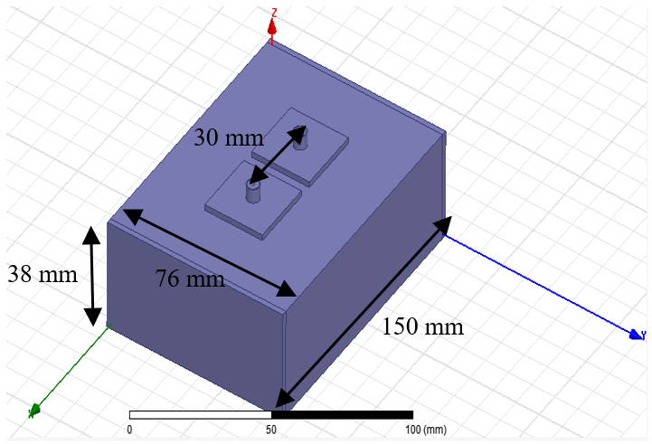
Figure 2. Rectangular waveguide design using connectors with position at 65/35 (TE₁₀ mode).
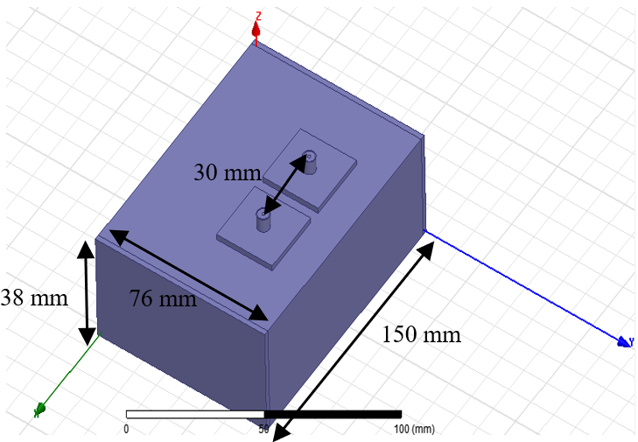
Figure 3. Rectangular waveguide design using connectors with position at 65/35 (TE₂₀ mode)
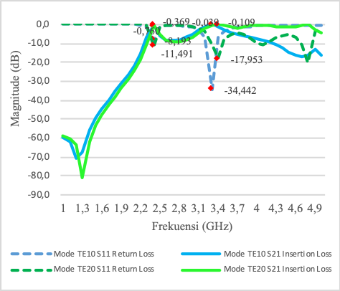
Figure 4. Rectangular waveguide chart using SMA Connectors with position at 65/35
seen in Figures 5 and 6. The design is using SMA connector that is located on x-axis, with rectangular waveguide of 100 mm. The positions of the connector are are shifted to 70 mm and 30 mm, previously at 65 mm and 35 mm. The center point is still located at 50 mm. Thus, the distance of the connectors from the center point is 20 mm. Figures 5 and 6 show the results of the TE₁₀ and TE₂₀ modes, respectively.
Figure 7 shows the graph of simulated results by using SMA connectors. In this simulation, the connector position is shifted and the connector position that is based on the x-axis is at the position of 70/30. By performing the connector shift, the obtained values of the parameters are changed, as illustrated in Figure 7 for TE₁₀ mode. The best filter response is at a cut-off frequency of 3.2 GHz with the value of return loss of -27.764 dB and an insertion loss of -0.044 dB. For the TE_{20 mode}, the best filter response is at the cut-off frequency of 3.3 GHz with the value of return loss of -36.624 dB and an insertion loss of -0.034 dB.
The results of the TE_{mn} rectangular waveguide mode design by performing a connector shifting position can be seen in Figures 8 and 9. This design is using SMA connector that is located on the x-axis, with a rectangular waveguide length of 100 mm. The positions of the connector are shifted to 75 mm and 25 mm, previously at 70 mm and 30 mm. The center point is still located at 50 mm. Thus, the distance of the connectors from the center point is 25 mm. Figures 8 and 9 show the results of the TE₁₀ and TE₂₀ modes, respectively.
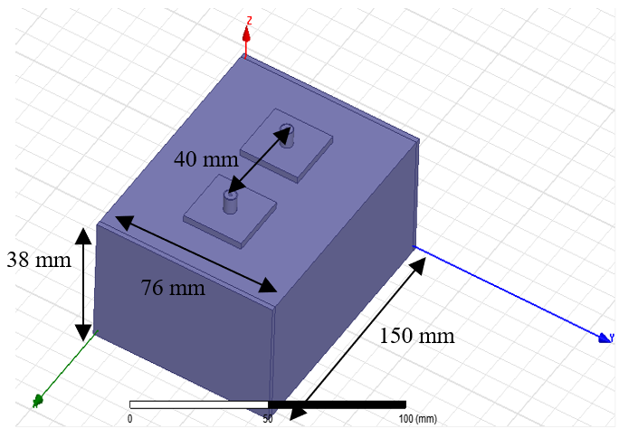
Figure 5. Rectangular waveguide design using connectors with position at 70/30 (TE₁₀ mode).
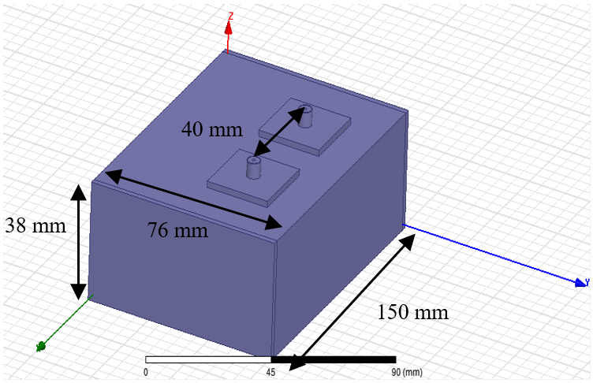
Figure 6. Rectangular waveguide design using connectors with position at 70/30 (TE₂₀ mode).
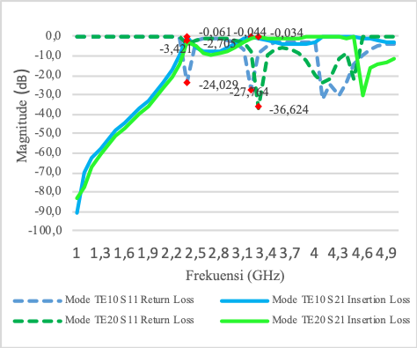
Figure 7. Rectangular waveguide chart using SMA Connectors with position at 70/30.
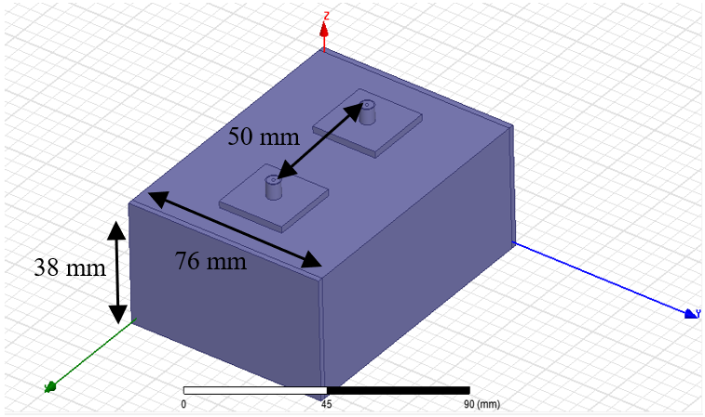
Figure 8. Rectangular waveguide design using connectors with position at 75/25 (TE₁₀ mode).
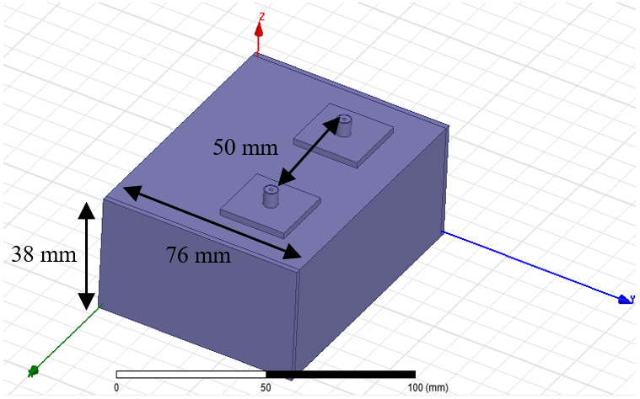
Figure 9. Rectangular waveguide design using connectors with position at 75/25 (TE₂₀ mode).
Figure 10 shows the graph of simulated results by using SMA connectors. In this simulation, the connector position is shifted, and the connector position that is based on the x-axis is at the position of 75/25. By performing the connector shift, the obtained values of the parameters are changed as illustrated in Figure 10 for TE₁₀ mode. The best filter response is at a cut-off frequency of 3.2 GHz with the value of return loss of -21.658 dB and an insertion loss of -0.067 dB. For the TE_{20 mode}, the best filter response is at the cut-off frequency of 3.3 GHz with the value of return loss of -26.062 dB and an insertion loss of -0.049 dB.
The results of the design of the TE_{mn} rectangular waveguide mode by performing a connector shifting position can be seen in Figures 11 and 12. The design is using SMA connector that is located on the x-axis, with a rectangular waveguide length of 100 mm. The positions of the connector are shifted to 80 mm and 20 mm, previously at 75 mm and 25 mm. The center point is still located at 50 mm. Thus, the distance of the connectors from the center point is 30 mm. Figures 11 and 12 show the results of the TE₁₀ and TE₂₀ modes, respectively.
Figure 13 shows the graph of simulated results by using SMA connectors. In this simulation, the connector position is shifted and the connector position that is based on the x-axis is at the position of 80/20. By performing the connector shift, the obtained values of the parameters are changed, as illustrated in Figure 13. For TE₁₀ mode, this configuration produces the best filter response.
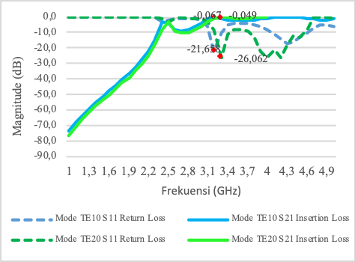
Figure 10. Rectangular waveguide chart using SMA Connector with position 75/25.
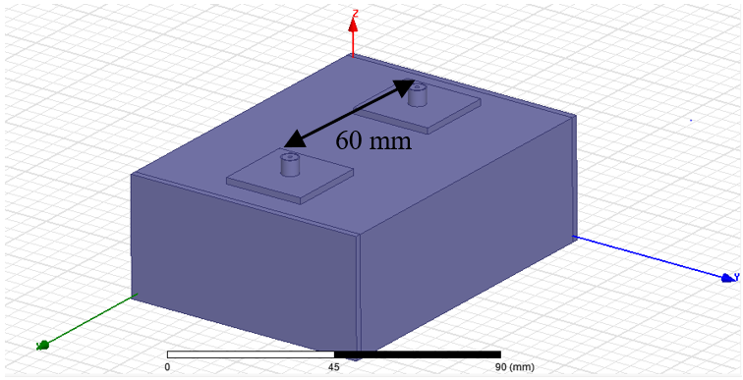
Figure 11. Rectangular waveguide design using connector with position 80/20 Mode TE10
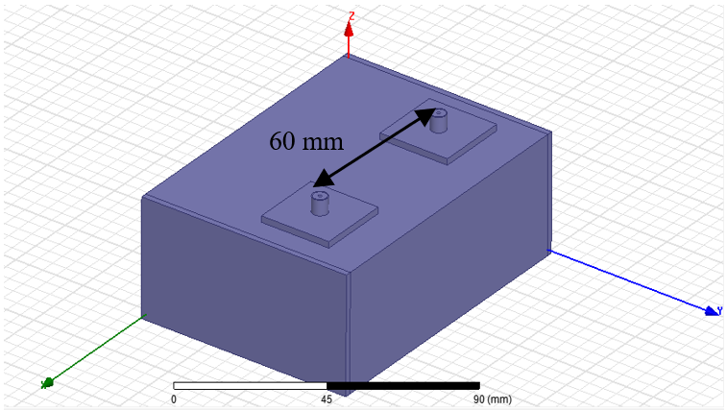
Figure 12. Rectangular waveguide design using connectors with position at 80/20 (TE₂₀ mode).
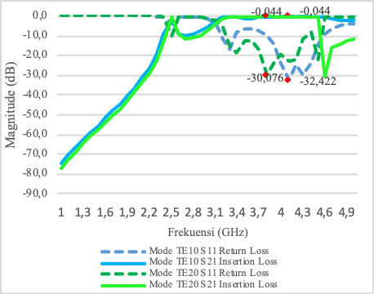
Figure 13. Rectangular waveguide chart using SMA Connectors with position at 80/20.
The cut-off frequency is shifted from 3.2 GHz to 4.1 GHz with the value of return loss of -32.422 dB and an insertion loss of -0.044 dB. For TE₂₀ mode, the filter response is also shifted, from previously at a cut-off frequency of 3.3 GHz to 3.8 GHz, with a return loss of -30.070 dB and an insertion loss of -0.044 dB. For this simulation scenario, although the obtained value of the return loss and insertion loss parameters are very well compared to the previous simulation results, the cut-off frequency for both modes shifted from the expected frequency.
The results of the design of the TE_{mn} rectangular waveguide mode by performing a connector shifting position can be seen in Figures 14 and 15. The design is using SMA connector that is located on the x-axis, with a rectangular waveguide length of 100 mm. The positions of the connector are shifted to 85 mm and 15 mm, previously at 75 mm and 25 mm. The center point is still located at 50 mm. Thus, the distance of the connectors from the center point is 35 mm. Figures 14 and 15 show the results of the TE₁₀ and TE₂₀ modes, respectively.
Figure 16 shows the graph of simulated results by using SMA connectors. In this simulation, the connector position is shifted, and the connector position that is based on the x-axis is at the position of 85/15. By performing the connector shift, the obtained values of the parameters are changed, as illustrated in Figure 16 for TE₁₀ mode. The best filter response is at a cut-off frequency of 3.4 GHz with the value of return loss of -21.971 dB and an insertion loss of -0.263 dB. For the TE_{20 mode}, the best filter response is at the cut-off frequency of 3.5 GHz with the value of return loss of -28.718 dB and an insertion loss of -0.045 dB.

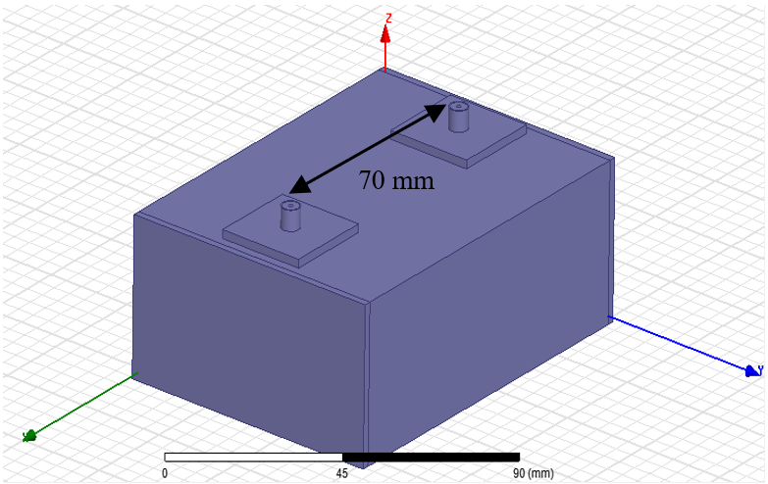
Figure 14. Rectangular waveguide design using connectors with position at 85/15 (TE₁₀ mode)
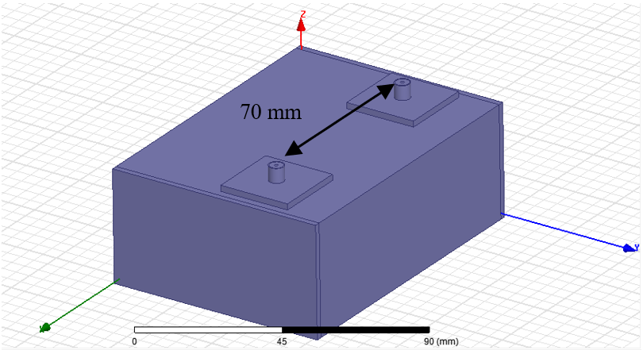
Figure 15. Rectangular waveguide design using connectors with position at 85/15 (TE₂₀ mode)
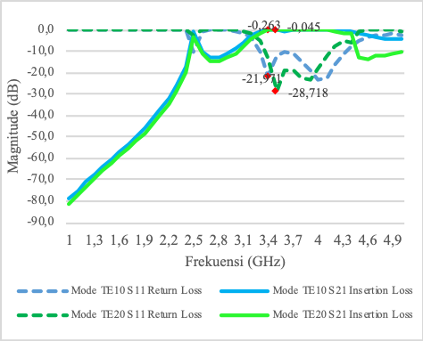
Figure 16. Rectangular waveguide chart using SMA Connectors with position at 80/20.
- Analysis of TE_{mn} Mode Rectangular Waveguide Design Using SMA Connector
After the optimization of the design, the simulation results are then analyzed. The best design is fabricated and then is measured using Vector Network Analyzer (VNA). Figure 17 shows a comparison chart of all simulated TE₁₀ mode rectangular waveguide results by shifting the connector position. Because the smaller the value of the return loss parameters is the better, the best return loss value is in the position of connector 65/35 and connector 80/20. However, for the connector position at 80/20, the parameter of the cut-off frequency is at 4.1 GHz, and the value is not in the expected frequency range of 3.3-3.5 GHz. Whereas, for connector position 65/35, the parameter of the cut-off frequency is at 3.3 GHz and the value is at the expected frequency range. In conclusion, for the TE₁₀ mode rectangular waveguide, the best performance is obtained when the connector is at position 65/35.
Figure 18 shows a comparison chart of all simulated TE₂₀ mode rectangular waveguide results by shifting the connector position. The best return loss value is at the connector position 70/30. However, as seen in Figure 18, for the position 70/30 connector, in one bandwidth there are three parameters of the cut-off frequency passed in the filter response. The required filter response in one bandwidth can only miss a slight cut-off frequency. For the 85/15 connector position, in one bandwidth simply skip two parameters of the cut off frequency and the best value at the position of the cut off frequency at 3.5 GHz.

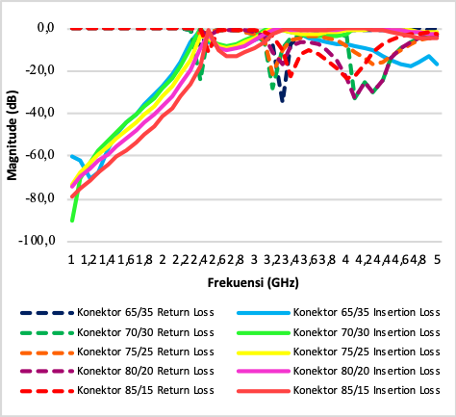
Figure 17. Comparison chart of simulated result shifting connectors on TE₁₀ mode.
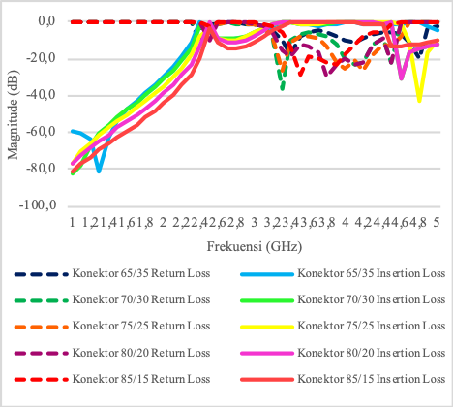
Figure 18. Comparison chart of simulated result shifting connectors on TE₂₀ mode.

- Power Field Raised in Simulation
Figure 19 shows the simulated electric field (E) in TE₁₀ mode rectangular waveguide. The highest value of electric field intensity is at the point of axis y = 36 mm (half of the waveguide width 72 mm) and z = 17 mm (half of the waveguide height 34 mm), where the intensity value of E = 27.3 V/M. Figure 20 shows the simulated electric field (E) in TE₂₀ mode rectangular waveguide. The highest value of electric field intensity is at the point of axis y = 48 mm (2/3 of 72 mm width) and z = 17 mm (1/2 of 34 mm width), where the intensity value E = 350 V/M.
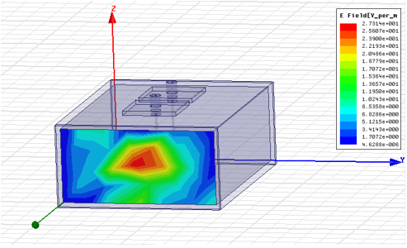
Figure 19. Simulated electric field in TE₁₀ mode.
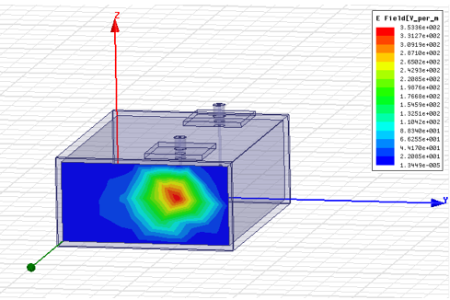
Figure 20. Simulated electric field in TE₂₀ mode.
- Design Realization
The fabricated rectangular waveguide that is based on the simulation can be seen in Figures 21 and 22.

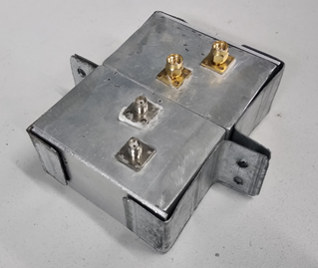
Figure 21. Realization of the design.

Table 1
Comparison Result between Measurement and Simulation
Simulation Results (65/35) |  |  |  |  |  | Measurement Results (with VNA)
TE₁₀ Mode |  |  | TE₂₀ Mode |  |  | TE₁₀ Mode |  |  | TE₂₀ Mode
F (GHz) | S₁₁ (dB) | S₂₁ (dB) | F (GHz) | S₁₁ (dB) | S21 (dB) | F (GHz) | S₁₁ (dB) | S21 (dB) | F (GHz) | S₁₁ (dB) | S₂₁ (dB)
3.3 | 34 | 0.39 | 3.4 | 17 | 0.109 | 3.2 | 18 | 2.7 | 3.2 | 5.89 | 4.31

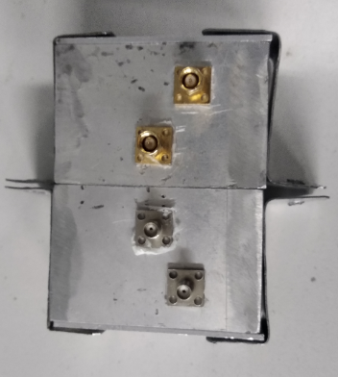
Figure 22. Realization of the design (top view).
After fabrication, the rectangular waveguide is then measured using Vector Network Analyzer (VNA) for both modes (TE₁₀ and TE₂₀). Based on the measurement results for the TE₁₀ mode, the cut-off frequency is at 3.2 GHz with the value of the return loss of -18.73 dB and an insertion loss of -2.70 dB. To compare, the simulated results at connector position 65/35 are: cut-off frequency = 3.3 GHz, return loss -34.442 dB, and insertion loss = -0.039 dB. This means that the performance of the fabricated device experiences a cut-off frequency shifting from 3.3 GHz to 3.2 GHz. Nevertheless, the values of the return loss and insertion loss are satisfactory.
The measured cut-off frequency for TE₂₀ mode is at a frequency of 3.2 GHz with the value of the return loss of -5.89 dB and an insertion loss of -4.31 dB. Because the value of the return loss is below than-3 dB and the value of the insertion loss is above -10 dB, it can be said that the obtained measurement results for the TE₂₀ mode is not better than the simulation. The simulated results for the TE₂₀ mode are better than the measured results with a cut-off frequency of 3.5 GHz, a return loss of -28.718 dB and an insertion loss of -0.045 dB.
Based on the comparison of the simulated and measurement results, there is a difference in the value of the parameters. The discrepancy is due to the dimensional changes in the manufacturing process (device fabrication). The fabrication process needs a high level of accuracy, and it is difficult to obtain a dimension that corresponds to the simulation. Results comparison between measurement and simulation can be seen in Table 1.

Conclusion
Based on the simulation of TE₁₀ mode rectangular waveguide using connectors, the best performance obtained at the position of 65/35 (30 mm distance between connectors) with a cut-off frequency of 3.3 GHz, a return loss of -34.442 dB and an insertion loss of -0.039 dB. While, for the simulated TE₂₀ mode rectangular waveguide using connectors, the best results are obtained at the position of 85/15 (distance between connectors = 70 mm) with a cut off frequency of 3.5 GHz, a return loss of -28.718 dB and an insertion loss of -0.045 dB.
The measured results of TE₁₀ mode rectangular waveguide with the connectors position adjacent to the filter response is at a cut-off frequency of 3.2 GHz with the value of the return loss of -18.73 dB and an insertion loss of -2.70 dB. Menwhile, the measured result of the TE₂₀ mode rectangular waveguide TE20 is at a cut-off frequency of 3.2 GHz with the value of the return loss of -5.89 dB and an insertion loss -4.31 dB.

Acknowledgement
We thank our fellow in Laboratory of Electrical Engineering Universitas Jenderal Achmad Yani which has provided assistance in this research.

References
[1] A. E. Karbowiak, “Microwave aspects of waveguides for long-distance transmission,” in Proc. IEE Part C Monogr., vol. 105, no. 8, pp. 360, 1958.
[2] S. E. Miller, “Waveguide as a communication medium,” Bell Syst. Tech. J., vol. 33, no. 6, pp. 1209–1265, 1954.
[3] E. F. Da Silva, J. S. Rocha, P. R. Lins, S. D. Da Nóbrega, and M. S. De Alencar, “Characterization of electromagnetic radiation absorber materials,” in Proc. SBMO/IEEE MTT-S Int. Microwave Optoelectronics Conf., 2005, pp. 326–329.
[4] G. Sindura, K. Ram Prakash, and P. Salil, “Control of electromagnetic waves through electromagnetic shielding,” in Proc. 2011 Int. Conf. Emerging Trends Elect. Comput. Technology, 2011, pp. 448–452.
[5] A. Sabouni, S. Noghanian, and L. Shafai, “Transverse electric and magnetic components of field measurement for microwave breast cancer imaging,” in Proc. 2010 14th Int. Symp. Antenna Tech. Appl. Electromagnetics American Electromagnetics Conf., 2010, pp. 1-4.
[6] D. F. Cui, Z. H. Chen, Z. Y. Yuan, Y. L. Zhou, H. B. Lu, and G. Z. Yang, “Transverse electric and transverse magnetic active intersubband transitions in GaAs/AlGaAs step quantum well,” in Proc. IEEE Lasers Electro-Optics Soc. 1994 7th Annu. Meeting, 1994, vol. 1, pp. 182–183.
[7] M. Omar, N. A. M. Zin, Z. I. A. Latiff, and N. A. Ismail, “Review on design of on chip band pass filter for radio frequency applications,” in Proc. 2016 7th IEEE Control Syst. Graduate Research Colloquium, 2016, pp. 148–152.
[8] D. Selvathi and M. Pown, “Design of band pass filter using active inductor for RF receiver front-end,” in Proc. 2014 Int. Conf. Commun. Network Technologies, 2014, pp. 296–301.
[9] N. Chakrabarti, S. Kalra, S. Saxena, and M. R. Tripathy, “Ultra-wideband antenna for a ground penetrating radar,” in Proc. 2016 Thirteenth Int. Conf. Wireless Optical Commun. Networks, 2016.
[10] F. Parrini et al., “ULTRA: Wideband ground penetrating radar,” in Proc. 2006 European Radar Conf., 2006, pp. 182–185.
[11] Y. Xu et al., “Design and test of broadband rectangular waveguide TE10 to circular waveguide TE21 and TE01 mode converters,” IEEE Trans. Electron. Devices, vol. 66, no. 8, pp. 3573–3579, Aug. 2019.
[12] H. S. Wu and C. K. C. Tzuang, “Artificially integrated synthetic rectangular waveguide,” IEEE Trans. Antennas Propag., vol. 53, no. 9, pp. 2872–2881, Sep. 2005.
[13] F. Teberio et al., “Rectangular waveguide filters with meandered topology,” IEEE Trans. Microw. Theory and Tech., 2018, vol. 66, no. 8, pp. 3632–3643.
[14] Z. Yu, “The miniaturization of rectangular waveguide,” in Proc. 2010 Int. Conf. Microw. Millimeter Wave Tech., 2010, pp. 1845–1848.

