Design and Performance Analysis of Linear Array

Microstrip Antennas with Mitered-Bends Feeding Network for X-Band Radar Applications

Bidadariana Yunia Utami Putri a,*, Eka Setia Nugraha a, Anantia Prakasa a, Subroto Fajar Siddiq b

a Fakultas Teknik Telekomunikasi dan Elektro

Institut Teknologi Telkom Purwokerto

Jl. D. I. Panjaitan No.128

Purwokerto, Indonesia

b Center for Technology and Innovation Division

PT. Len Industri (Persero)

Jl. Soekarno Hatta 442

Bandung, Indonesia

**Abstract**

To accurately detect objects, the radar antenna must have a high gain for the desired range. The antenna uses an array method to increase the gain. It has a unidirectional radiation pattern to meet the X-band radar implementation as a ship navigation tool. The X-band radar works at high frequencies. Thus, it will be more sensitive in detecting small particles, including rain particles. The use of a mitered-bends feeding network method by cutting the 90-degree curve is to maximize the power transmitted to reduce losses. This method spreads the bandwidth of the antenna. The antenna is designed and fabricated into a linear array of 8 elements, using the R04003C Rogers substrate with a microstrip line supply. This study limits up to 8 elements of radiation, followed by the addition of a method to expand the bandwidth of antennas. Considering material limitation and duration of antenna design. The final antenna dimensions are 142.40 mm × 42.8 mm*.* The measuring results show fc = 9.496 GHz, S11 = -32.64 dB, VSWR 1.05, bandwidth = 41.9 MHz (9.5159 GHz - 9.4740 GHz), and gain 8.8 dB as well as a linear polarized antenna with unidirectional pattern direction. The radar antenna tends to have a narrow beamwidth and high gain.

Keywords: X-band radar, microstrip antennas, linear array, mitered-bends, gain, unidirectional

# Introduction

In the telecommunication field, especially in the radar communication system and navigation, are required an accurate radar system to detect an object movement, the radar works in a similar way to echo signal [1], [2]. The X-band radar working on the electromagnetic spectrum with a frequency range of 8 GHz - 12 GHz [1], [2]. This radar is quite sensitive for detecting small particles. X-band display radar produces high-resolution object catches [1].

In general, the X-band radar can be used for maritime radar as a ship navigation function, as well as a weather radar with antenna requirements working on the same spectrum [1]. Antenna, the most necessary part of radar, acts as a transducer between the propagation of free space and the propagation of the guided waves [3]. The antenna can determine the overall radar system performance, especially for received signal processing [2], [4]. Radar antenna selection should adjust the specifications of the radar as needed.

The navigation radar is used on marine vessels to detect other vessels or other objects around it. To reach distant objects, high gain antennas are required [1], [2], [4]. On the other hand, the X-band radar is capable of detecting rain grains so it can be applied as a weather radar [1]. Ideally, how close or distant the radar targets are, the accuracy of detection should still be noticed. The principle, the wider the bandwidth of the signal provided, the better the resolution parameters. Also, the further the radar target, the higher the radar's working frequency and the smaller of the main lobe antenna is needed.

*\** Corresponding Author*.*

Email: 15101075@ittelkom-pwt.ac.id

Received: November 29, 2019 ; Revised: March 05, 2020

Accepted: March 12, 2020 ; Published: August 31, 2020

© 2020 PPET - LIPI

25-32

Therefore, the study was conducted by designing a radar antenna using a 1x8 linear array method with a multilevel impedance of 50 Ω, 70.71 Ω, and 100 Ω [5]. The channel length uses a quarter-wave transformer, to meet the distance between elements. On the other hand, the antenna works at a relatively high frequency of 9.5 GHz, causing the antenna dimensions to become smaller, thus much attenuating other objects around the antenna that will affect the outcome of the antenna parameters [4], [3]. It takes an antenna design with an array method aimed at enlarging the antenna gain value [4], [6], [7].

To distinguish this with previous research, the antenna design was done by adding the mitered-bend feeding network method on each of the 90-degree channels and antenna T-junction channels. Mitered-bends have the advantage of reducing losses in antenna channels so that the transmitted power is more optimal, thereby increasing the antenna gain [5]. Another method in this research is the use of the Rogers R04003C substrate material. The material has the appropriate characteristics to be applied at high frequencies [8]. This method will produce an antenna matching that will improve the overall performance of the antenna, one of which is bandwidth and gain. This research is expected to be used as a reference for the next X-band radar antenna design.

# Methodology

## Antenna Specifications

An 8-elements linear array microstrip antenna using a rectangular patch is designed to work on the X-band radar. The first phase of the antenna design is determining the characteristics of the antenna required [1], [9], where the antenna requirements are shown in Table 1.

The antenna design uses the Rogers R04003C type substrate has a material permittivity $\left(ε_{r}\right)$ of 3.55 with a thickness $\left(h\right)$ of 1.524 mm. Selection of Rogers R04003C material because the material is relatively more stable and suitable for application at high frequencies (X-band) [8]. Besides, the materials used to make patches and ground plane parts are made from conductor material that is copper with a thickness of 0.035 mm.

## Method

After determining the antenna specification requirements, the next step is to calculate the antenna dimensions and design the antenna according to the design in the flowchart in Figure 1.

The design began with designing a single patch antenna, an array of 4 elements, an array of 8 elements, and the addition of a mitered-bends method on an array of 8 elements. The antenna simulation process utilized the CST Studio Suite 2018 software. The antenna iteration was performed until the required antenna parameters have met.

The realization of antennas is based on the final design of the antenna, which resulted in a performance comparison between simulation and measurement results. Later, further analysis is needed if there is any deviation in the antenna prototype measurement.

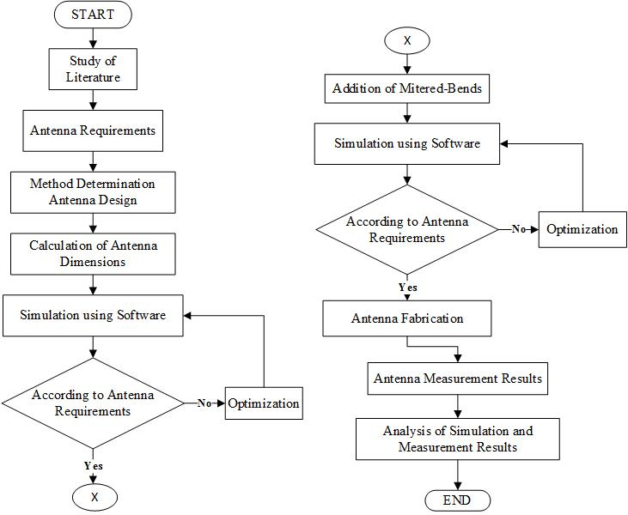

Figure 1. Flowchart of antenna design

Table 1

Antenna Specification

|  |  |
| --- | --- |
| **Parameters** | **Antenna Requirements** |
| Working Frequency | $$9.5 {GH}_{z}±30 {MH}_{z} \left(X-band\right)$$ |
| Impedance | $50 Ω$ |
| VSWR | $$≤2.0$$ |
| Gain | $$≥8.0 dB$$ |
| Bandwidth | $$≥225 {MH}_{z}$$ $$\left[f_{h}\left(9.6 GHz\right)-f_{l}\left(9.375 GHz\right)\right]$$ |
| Return loss $\left(S_{11}\right)$ | $$≥-20 dB$$ |
| Polarization | Linear |
| Radiation Pattern | Unidirectional |

The calculations on the antenna dimensions include substrate dimensions, patch dimensions, and antenna channel dimensions. On the ground plane, dimensions have the same size as the substrate dimensions $\left(W_{g}=W_{s}\right)$ and $\left(L_{g}=L_{s}\right)$.

Groundplane width $\left(W_{g}\right)≥6h+W$ (1)

Groundplane length $\left(L_{g}\right)≥6h+L$ (2)

Where $h$ is substrate thickness, $W$ is the width of the patch, and $L$ is the length of the patch. On the rectangular antenna patch can be calculated with (3) [10].

$W=\frac{c}{2f_{r}\sqrt{\frac{{(ε}_{r}+1)}{2}}}$ (3)

$W$ is the patch width $(mm)$, $c=3×{10}^{8} m/s$ (speed of light), $f_{r}$ is the frequency of resonance, and $ε_{r}$ is dielectric material permittivity. If the value of the effective dielectric constant is worth $\left(W/h>1\right)$ then use (4):

$ε_{reff}=\frac{ε_{r}+1}{2}+\frac{ε_{r}-1}{2}\left(\frac{1}{\sqrt{1+12(\frac{h}{W})}}\right)$ (4)

$ε_{reff}$ is an effective dielectric constant, As for $\left(W/h<1\right)$ is expressed with (5).

${\text{ε}}_{\text{reff }}\text{ =}\frac{{\text{ε}}_{\text{r}}\text{ + 1}}{\text{2}}\text{+}\frac{{\text{ε}}_{\text{r}} \text{- 1}}{\text{2}}\left(\frac{\text{1}}{\sqrt{\text{1+12 }\left(\frac{\text{h}}{W_{f}}\right)}}\right)$ (5)

To specify the dimensions of the patch length $\left(L\right)$, the parameter of $\left(∆L\right)$ is needed. $It$ is an increase in length from $\left(L\right)$ due to the fringing effect. Length increase $\left(∆L\right)$ is formulated as (6) [10].

$∆L=0.412 h \frac{(ε_{reff}+0.3)(\frac{W}{h}+0.264)}{(ε_{reff}+0.258)(\frac{W}{h}+0.8)}$ (6)

$L_{eff}$ is determined by (7).

$L_{eff} =\frac{c}{2f\sqrt{ε_{reff}}}$ (7)

Therefore, the length is known from the patch $\left(L\right)$ according to (8).

$L ={\text{L}}_{\text{eff}} \text{- }\text{2}\text{ ∆L}$ (8)

The antenna channel design uses the T-junction (power divider) technique as seen in Figure 2 [5], with a total impedance of $50 Ω$. Line of the multi-level impedance is the impedance of $50 Ω$, $70.71 Ω$, dan $100 Ω$. Channel-owned impedance determines the dimensional change of the antenna channel width. This will determine the matching impedance condition. The multiple-level impedance method aims to achieve a matching impedance condition. So there is no reflection on the source (transmitter), and antenna power transfer occurs maximum. Besides, matching impedance conditions are required to minimize losses in transmission lines [3].

The $\frac{1}{4}λ_{g}$ transformer is a matching impedance technique by delivering a transmission line with the $Z_{L}=70 Ω$ impedance between two transmission channels that do not match.

$Z_{L}=\sqrt{Z_{0} x{ Z}_{B}}$ (9)

Where $Z_{0}$ is $50 Ω$ impedance, ${ Z}_{B}$ is $100 Ω$ impedance. As for determining the impedance of the $100 Ω$ channel load is known from (10), the input power of the channels are divided into the ratio of 1:1 [10], [11].

$Z_{1}=Z_{2}=Z_{B}$ (10)

The formula for determining the width dimensions of a microstrip channel is visible in (11) [5], [10].

$Wf=\frac{2(h)}{π}\left\{B-1-\ln\left(2B-1\right)+\frac{ε_{r}-1}{2ε_{r}}\left[\ln\left(2B-1\right)+0.39-\frac{0,61}{ε_{r}}\right]\right\}$ (11)

$B =\frac{60{(π)}^{2}}{Z_{0}\sqrt{ε_{r}}}$ (12)

The length of the microstrip channel is done by looking for effective dielectric constant value *($ε_{reff}$**)* in each channel impedance from the value $λ_{g}$. It can be obtained by (13) [10].

$λ_{g}=\frac{λ_{0}}{\sqrt{Ԑ_{eff}}}$ (13)

Therefore the length of antenna channels is $l=\frac{λ_{g}.}{4}$.

$D=W_{f}\sqrt{2}$ (14)

$X=D\left(0.52+0.65e^{-1.35x\frac{W_{f}}{h}}\right)$ (15)

$A=(X-\frac{D}{2})\sqrt{2}$ (16)

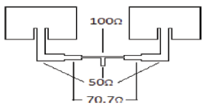

Figure 2. Corporate-feed method (T-junction) on array microstrip with transformer $\frac{1}{4}λ_{g}$

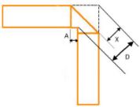 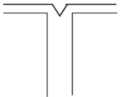

1. (b)

Figure 3. Mitered-bends (a) channel mikrostrip 900 (b) mitered “T” bend

$D$ is the diagonal of a square miter; by these value the dimension of truncation channel $\left(X\right)$ can be specified as seen in Figure 3. The *X* value can be searched by involving the width of the channel to be cut $\left(W_{f}\right)$ and the height of the substrate $\left(h\right)$. $A$ is the length of compensation for an optimal bend. There is the addition of the channel length dimension at the time of channel cutting that aims to make the bend more optimal [5], [7].

# Results and Analysis

The array microstrip antenna should have a central frequency $\left(f_{c}\right)=9.5 {GH}_{z}$ to work on the X-band radar. It is expected that the antenna design can approach the function and performance of the antenna required on the X-band radar so that it can be used as a reference in the next X-band radar antenna manufacturing project.

## Antenna Simulation

Antenna is gradually designed. It starts from single-element designing, 2-element arrays, 4-element arrays, 8-element arrays, and added mitered-bends methods on the design of an antenna 8-element arrays as seen in Figure 4. It aims to facilitate the arrangement of antenna arrays, knowing the antenna matching conditions. So it is easier to analyze the performance of the resulting parameters.

The antenna matching conditions on the single element used the inset-fed iteration method so that a good parameter is obtained. The single microstrip antenna has a gain of 5.65 dB. The value of the gain is still far from the expected gain value of ≥ 8 dB. The antenna needs a method to increase the gain, including the addition of the number of elements with 2N provision of the antenna (array method) [3]. Some references also mention that the mitered-bends method can increase the gain. The antenna on the radar has a high gain to detect distant objects. Each of the designed antenna has resulted of S11, VSWR, and different gain. Each addition of the antenna elements will increase the gain. Difference parameters of S11, *VSWRm* and bandwidth depend on the matching impedance of the antenna.

The next step is to design a 4-element antenna and 8 elements ones with a linear array method [6], [9]. To achieve antenna matching, the distance between is adjusted as far as λ/2 [10]. The distance between antenna radiating elements can be fulfilled by optimizing the length of antenna channels 50 Ω, 70.71 Ω, and 100 Ω.

The antenna’s final dimensions have a total size of 142.40 mm × 42.8 mm. A comparison of the calculated antenna dimensions with the final dimensions of simulation design can be seen in Table 2. The final dimension of the antenna is the result of iteration, where the antenna optimization is run to achieve the specified parameter value.

A comparison table of antenna parameter results on the antenna design using simulated software can be seen in Table 3.

Table 3 shows that the antenna design phases result in increased and decreased $S_{11}$, according to the level of matching antenna that is owned. Overall, the design of the antenna is working according to specifications: $9.5 {GH}_{z}$ frequency, $S_{11}≥-20 dB$, and $VSWR ≤2$.

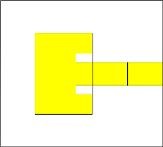 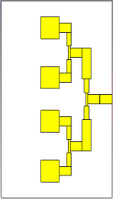

1. (b)

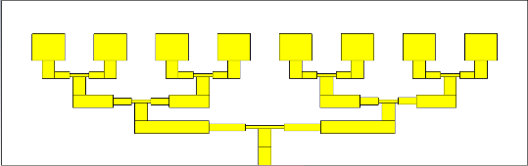

(c)

Figure 4. (a) Single microstrip antenna, (b) array of 1×4 microstrip antenna, (c) array of 1×8 elements

Table 2

Dimensions on Antenna Design

|  |  |  |
| --- | --- | --- |
| **Component** | **Calculation Value $$\left(mm\right)$$** | **Final Dimensions $$\left(mm\right)$$** |
| Patch Width $\left(W\right)$ | 10.46 | 10.70 |
| Patch Length $\left(L\right)$ | 9.27 | 7.61 |
| Width of feed line $\left(W_{f}\right)$ | 3.43 | 3.28 |
| Length of feed line $\left(L_{f}\right)$ | $\frac{{λ_{g}}_{50}}{2}$ = 9.46 | 9.46 |
| Channel Length $50 Ω \left(l_{50}\right)$ | $λ_{g(50)}$ = 18.93 | 20.0 |
| $\frac{λ_{g(50)}}{2}$ = 9.46 | 10.83 |
| $\frac{{λ_{g}}_{50}}{4}$ = 4.73 | 4.73 |
| Channel Width $70 Ω \left(W_{70}\right)$ | 1.845 | 1.79 |
| Channel Length $70 Ω \left(l_{70}\right)$ | $\frac{λ_{g(70)}}{2}$ = 9.68 | 9.67 |
| $\frac{λ_{g(70)}}{4}$ = 4.84 | 4.83 |
| Channel Width $100 Ω \left(W_{100}\right)$ | 0.8 | 0.785 |
| Channel Length $100 Ω \left(l_{100}\right)$ | $\frac{λ_{g(100)}}{2}$ = 9.89 | 9.88 |
| $\frac{λ_{g(100)}}{4}$ = 4.94 | 4.94 |
| Substrate Width $\left(W_{s}\right)$ | 19.6 | 42.8 |
| Substrate Length $\left(L_{s}\right)$ | 18 | 142.4 |
| $D$ (The diagonal of square miter) | 4.59 | 4.59 |
| $x$ (Truncated channel dimensions) | 2.55 | 2.55 |
| $A$ (Compensated length for optimal bend) | 0.367 | 0.367 |
| $d$ (Patch distance) | 15.78 | 16.50 |

Table 3

Comparison of Antenna Design Simulation Result

|  |  |  |  |  |  |
| --- | --- | --- | --- | --- | --- |
| **Element** | **Antenna Parameters** | | | | |
|  | $$f_{r}$$ $\left({GH}_{z}\right)$ | $$S_{11}$$ $$\left(dB\right)$$ | $$VSWR$$ | **BW $\left({MH}_{z}\right)$** | **Gain $$\left(dB\right)$$** |
| Single Element | $$9.5$$ $$\left({GH}_{Z}\right)$$ | -34.72 | 1.03 | 460 | 5.65 |
| 4  Element | -21.2 | 1.19 | 410 | 10.94 |
| 8  Element (original) | -29.43 | 1.06 | 450 | 15.88 |
| 8  Element (Miter-Bends) | -22.33 | 1.16 | 480 | 15.71 |

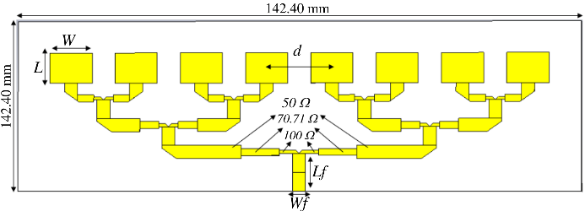

Figure 5. Design of 8 elements arrays with mitered-bends method

The array method proved to increase gain. On the single element, the antenna has a 5.6 dB. The value of gain on an array 4-elements has a 10.94 dB. And an array of 8 elements has a gain of 15 dB. Radar requires high gain value, to be able to capture distant signal objects. So the higher the gain value on the antenna, the better the result. But in this research, it is limited up to 8 elements of radiation, followed by the addition of a method to expand the bandwidth of antennas. The considerations are material limitation and duration of antenna design.

Some cases require that the radar antenna has a wide bandwidth for the antenna to recognize the object signal in the radar catchment area and has a distant radar range. Then the addition of the mitered-bend method aims to widen the antenna bandwidth. Mitered-bend methods can maximize the power transmitted [5]. So it has the perfect matching antenna level, as shown in Figure 5.

The mitered-bend method of the final antenna design can provide a bandwidth widening effect of 30 MHz. With the value of bandwidth before the addition of mitered-bends is 450 MHz. Whereas after the application of the mitered-bend method, the bandwidth antenna becomes 480 MHz.

## Comparison of Simulated and Measurement Results

Simulated results will show the parameter's value of the antenna design performance, so the overview of the antenna performance is known. When the antenna is fabricated, and then measurements are being carried out, it did not include the possibility of deviation. Therefore, there is a tolerance limit on the resulting antenna parameters. The design of the antenna using simulated software will place the antenna in an ideal position. Different when the antenna is realized, there will be a loss or noise that causes deviation. From these results, we can analyze the causes of deviations. Antenna fabrication results can be seen in Figure 6.

### Return Loss

The S-parameter (return loss) within this configuration is shown in Figure 7. This antenna array has shown a good return loss of -22.33 dB for simulation results and -32.64 dB for measurement results at 9.5 GHz resonant frequency. Comparison between simulation and measurement of -10.31 dB. This antenna met the expected antenna specification requirements that have an $f_{c}=9.5 {GH}_{z}$, and $S_{11}≥-20 dB$.

Simulated results indicate that the X-band antenna in the frequency range has the potential to produce multiband frequencies.

### Voltage Standing Wave Ratio (VSWR)

The comparison of VSWR results can be seen in Figure 8. The graph shows the comparison of VSWR values of simulated and measurement results. The simulation result show VSWR 1.16. While the VSWR measurement result is 1.05, both results meet the requirements of the desired VSWR value $\left(VSWR≤ 2.0\right)$. The most desirable condition is $VSWR=1$ so that there is no reflection and channel in the perfect condition $\left(Γ=0\right)$ [3]. But to achieve a perfect matching antenna condition is difficult, so the value of the VSWR should less than $\left(≤ 2.0\right)$. VSWR measurements are done to find out how the reflector signals form a wave [12]. The higher the VSWR, the worse the antenna performance.

Bandwidth parameters of the design can be known through the VSWR graph by giving a marker on the frequency range when $VSWR=2$. Then it is calculated using (17) [12].

$BW=f_{h}-f_{l}$ (17)

With $BW$ = bandwidth , $f_{h}$ = high frequency, and $f_{l}$ = lower frequency. The antenna simulation results work on the frequency range $\left(9.23 {GH}_{z}-9.71 {GH}_{z}\right)$ generating a bandwidth of $480 {MH}_{z}$. While the measurement results, the antennas work on the frequency range $\left(9.5159 {GH}_{z}-9.4740 {GH}_{z}\right)$ generating a bandwidth of $41.9 {MH}_{z}$. From these results, it is known that antenna measurements have bandwidth deviations. The measured bandwidth is only 8.8% of the simulated results. Many factors can affect the occurrence of deviation in the measurement of antenna parameters, one of which is in the less precise fabrication proses [12].

### Radiation Pattern and Gain

The antenna radiation pattern will show the antenna radiation direction as space coordinate function [10]. Design simulation results can depict antenna radiation in 3D form as seen in Figure 9. To detect distant objects, the radar must have a distant capture distance. So that the antenna tends to have a narrow beamwidth and high gain [6]. Figure 10 showed the radiation pattern of the antenna.

In remote field measurements, the distance between the AUT (Antenna Under Test) with the reference antenna must meet the requirements of the far-field, as well as the altitude fulfilling the fresnel area [10].

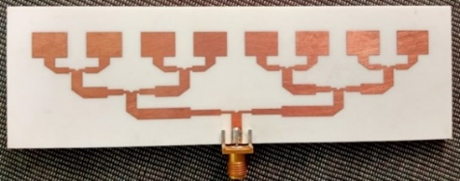

Figure 6. Realization of final antenna design

Figure 7. Differences Result of S11 Simulation and Measurement

Figure 8. Differences Result of VSWR Simulation and Measurement

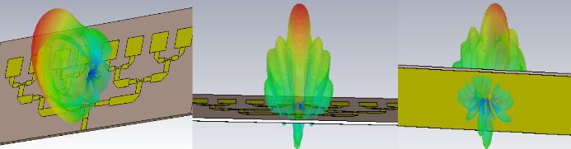

Figure 9. 3D of The Antenna Design

By comparing the radiation pattern as seen in Figure 10, the simulation results showed that the azimuth radiation pattern at a 0-degree angle has a receive power level of – 21.07 dB, while the antenna prototype shows a value of -39.0 dB. From the results of the pattern, it indicates that the antenna has a unidirectional radiation pattern, as what the antenna specification requires.

Next is the measurement of antenna gain parameters. The measurements are carried out by comparing the signal power level of the tester antenna (horn antenna) with the receiving power level of AUT (Antenna Under Test). The horn reference antenna used in far-field measurement includes a frequency of $700 {MH}_{z}-18 {GH}_{z}$ and has a gain of 11.8 dB at a frequency of $9.5 {GH}_{z}$ based on the datasheet. So the gain antenna of measurement results can be calculated by (18).

$G_{AUT\left(dBi\right) = }\left(P_{AUT(dBm)}-P_{REF(dBm)}\right)+G_{ref(dBi)}$ (18)

= (-39 - (-36) + 11.8)

= 8.8 dB

Where $G_{AUT\left(dBi\right)}$ is the antenna gain measured, $P_{AUT(dBm)}$ is the power level that AUT receives, $P_{REF(dBm)}$ is the power level receive antenna reference, and $G_{ref(dBi)}$ is gain antenna references. So it is known that the gain value of the antenna prototype is 8.8 dBi. While the simulation results, the antenna has a gain of 15.7 dB. The antenna prototype is only able to achieve a gain of 50.1% from simulated reinforcement.

Table 4 shows the comparison of the antenna parameters of the simulation and measurement results. Deviations occur in bandwidth and gain. The results of simulated have bandwidth value of 480 MHz, while the measurement of the antenna prototype show only reaches 41.9 MHz. The minimum bandwidth that an antenna should achieve is a minimum of $60\%$ of the specified frequency range. $BW=60\%×225 MHz=135 MHz$. By interpreting this, the resulted antennas are still capable of working properly.

The gain measurement reaches 8.8 dB or 50.1% of the simulated results (15.70 dB). Even though the gain



Figure 10. Differences Result of Radiation Pattern Simulation and Measurement

Table 4

Comparison Parameter Results of Simulated and Measurements

|  |  |  |
| --- | --- | --- |
| **Parameters** | **Simulation** | **Measurements** |
| Frequency | $$f_{c}=9.5 {GH}_{z}$$ | $$f_{c}=9.496 {GH}_{z}$$ |
| Return loss (S11) |  |  |
| VSWR |  |  |
| Bandwidth | $$\left(f_{h}\right)=9.71 {GH}_{z}$$ $$\left(f_{l}\right)=9.23 {GH}_{z}$$ $$BW=480 {MH}_{z}$$ | $$\left(f_{h}\right)=9.4740 {GH}_{z}$$ $$\left(f_{l}\right)=9.5159 {GH}_{z} \\ BW=41.9 {MH}_{z}$$ |
| Impedance | $$50 Ω$$ | $$49.649 Ω$$ |
| Polarization | Linear | Linear |
| Gain | $$15.71 dB$$ | $$8.8 dB$$ |
| Radiation Pattern | Unidirectional | Unidirectional |

measurement is not the same as simulated results, the gain on the antenna prototype has fulfilled the minimum value of the gain that antennas must achieve according to the requirements (gain≥8.0 dB). The antenna has a unidirectional radiation pattern and linear polarization. The result of the parameters in the simulation software already meets the requirements of antenna design specifications.

However, the measurement results show that there is some deviation from the parameters of bandwidth and gain. The deviation in the prototype antenna measurement results generally occurs often, given when designing the simulation design is all in ideal conditions. Different when the antenna is realized, wherein the process of fabrication antenna has a lot of risks that will cause a shift in the resulting parameters.

The risks that may occur during the antenna realization process are a less precise fabrication. Also, a slight change in the antenna dimensions when printed will cause a shift. The shift causes the measurement results do not match the simulation results, which in this case, the deviation from the bandwidth and gain on the antenna parameters. To overcome this, antenna fabrication should be done carefully and very precisely by adjusting the dimensions of the simulation results. However, the problem can be solved during the radar signal processing stage. Radar filters can eliminate some of the unexpected components or features of a signal so that the radar can meet the required specifications.

# Conclusion

This research has designed an array 8-elements of microstrip antenna to work on the X-band radar application with a working frequency of 9.5 GHz. Based on the results of the design, antennas showed that the array method could increase the gain. Increased gain on a design of approximately 5 dB. The important thing that distinguishes previous research, the antenna uses the miter-band feeding network method in the arrangement of an antenna array of 8-elements. The addition of the mitered-bends method at the final antenna design resulted in a bandwidth of 480 MHz, proven to widen bandwidth from the previous design, which is 450 MHz. The antenna has a unidirectional radiation pattern and linear polarization. The deviation between simulating and antenna measurements can be caused by many factors. However, simulated results indicate that the antenna already produces good parameters and meets the specified requirement specifications. To meet the standard specifications of the X-band antenna radar in the field so that it can be applied, it requires more research to add more arrays so that the antenna has a very high gain to have a wider coverage. For further research, it is advisable to add a slot method on the radiating element or use the defected creates Ground Structure (DGS) method on the antenna design to increase the bandwidth.

# Acknowledgment

This project was supported by the Center for Technology and Innovation Division of PT. Len Industri (Persero) Bandung, which supports all processes of antenna design to measurement, and guidance from the lecturers at Telkom Institute of Technology Purwokerto so that the research can be done well.

# References

[1] A. Awaludin, G. A. Nugroho, and S. A. Rahayu, “Analysis of furuno marine radar 1932 Mark-2 capability to observe rain rate,” *J. Aerosp. Sci*., vol. 10, no. 2, pp. 90-103, 2013.

[2] M. I. Skolnik, “Introduction to Radar Systems,” in *Radar Handbook*, 2nd ed., United States: McGraw-Hill, 1990.

[3] M. Alaydrus, *Antena Prinsip dan Aplikasi,* 1st ed., Yogyakarta: Graha Ilmu, 2011.

[4] R. Riyanto, H. Wijanto, and Y. Wahyu, “Perancangan dan realisasi susunan mikrostrip X-Band untuk aplikasi radar maritim,” in *e-Proc. Eng.*, vol. 2, no. 2, pp. 2520-2531, 2015.

[5] D. Prabhakar, P. M. Rao, and M. Satyanarayana, “Design and performance of resonant spacing linear patch array with mitered bend feed network for wireless applications,” *Indian J. Sci. Technol.*, vol. 10, no. 31, pp. 1-12, 2017.

[6] E. T. Rahardjo, D. P. Yusuf, Basari and F. Y. Zulkifli, “Microstrip array antenna for X-band radar application,” in *Proc. 2015 Asia-Pacific Microw. Conf.*, 2015, pp. 1-3.

[7] I. Atas, T. Abbasov, M. B. Kurt, and A. R. Celik, “High gain , directional and triple band rectangular microstrip array antenna design,” in *Proc. Int. Conf. Adv. Technol. Sci. 2016*, 2016, pp.549-553.

[8] M. Patel, P. Kuchhal, K. Lal, and R. Mishra, “Design and analysis of microstrip patch antenna array using different substrates for X-band applications,” *Int. J. Appl. Eng. Res.*, vol. 12, no. 19, pp. 8577-8581, 2017.

[9] Jonifan, W. Supriyatin, Y. Rafsyam, T. Firmansyah, Herudin, and A. Herudin, “Perancangan antena mikrostrip patch circular menggunakan metode array 1×8 untuk aplikasi radar maritim frekuensi3,2 GHz,” *Jurnal Ilmiah Setrum*, vol. 5, no. 2, pp. 77-81, 2016.

[10] C. A. Balanis, *Antenna Theory Analysis and Design*, 3rd ed., Canada: A John Wiley & Sons, Inc., Hoboken, New Jersey, 2005.

[11] R. Kaul, “Microwave engineering,” *IEEE Potentials*, vol. 8, no. 2, pp. 11-13, 1989.

[12] K. Paramayudha, A. P. Sari, H. Wijanto, Y. Wahyu, “Design and Implementation of planar fourtear microstrip antenna for WLAN and WiMAX applications,” *Jurnal Elektronika dan Telekomunikasi*, vol. 16, no. 1, pp. 20-24, 2016.