Subscriber Growth Forecasting of LTE Network 1800 MHz FDD at Denpasar City using Monte Carlo Simulation
Suci Rahmatia*, Azmi Azizah Azzahra, Muhammad Ismail, Dwi Astharini, Octarina Nur Samijayani
Department of Electrical Engineering
Faculty of Science and Technology, Al Azhar University of Indonesia
Jl. Sisingamangaraja Kebayoran Baru
Jakarta Selatan, Indonesia

Abstract
LTE is the 8th technology officially developed by the 3rd Generation Partnership Project (3GPP). The LTE technology is a solution that is used by engineers to resolve the problems of improving the quality of communications services. The LTE technology able to deliver up to 300 Mbps and 75 Mbps for downlink and uplink, respectively. This study aims to determine the maximum subscriber connected for LTE network technology with capacity planning at 1800 MHz Frequency Division Multiplexing for subscriber growth forecasting in 2025 at Denpasar city. The simulation used Atoll radio network planning software with the Monte Carlo method. Monte Carlo was used to investigating the increase in user throughput according to customer distribution, path loss, and services provided. This simulation is based on traffic data from traffic maps, lists of subscribers and user penetration and cellular services. Monte Carlo simulation shows the results in 2017 which 99.8% of users were successfully connected and only 0.2% of users were rejected. For forecasting in 2025, 99.3% of users are successfully connected, and only 0.7% of users are rejected.

Keywords: LTE Network, Frequency Division Multiplexing, Capacity Planning, Monte Carlo Simulation.

Introduction
The theoretical capacity of the network is limited by the number of eNodeB’s installed in the system. At a certain level of quality of service (QoS) such as throughput or probability of users being received or blocked, it is necessary to have capacity planning. Several factors affect capacity in a cell, such as the level of interference, supporting modulation, and coding schemes. Link budget calculations in coverage planning previously provided the maximum allowed path loss and maximum range of the cells. In the LTE network, the main indicator of capacity is the SINR distribution in the cell. In order to be able to get an optimal capacity planning, it is necessary to estimate the appropriate of throughput cell to decrease the cell radius and the need for traffic analysis to obtain traffic requests such as number of customers, mix of traffic and data about the geographical distribution of customers in the distribution area[1].
A capacity planning analysis requires a Monte Carlo simulation. This simulation also aims to test reliability in previous simulations, namely predictive coverage simulation. Monte Carlo simulation is used to increase user throughput according to customer distribution, path loss and services provided. This simulation is based on traffic data from traffic maps, lists of subscribers and user penetration and cellular services.
* Corresponding Author.
Email: suci@uai.ac.id
Received: October 04, 2018 ; Revised: December 06, 2018
Accepted: May 08, 2019 ; Published: August 31, 2019
© 2019 PPET - LIPI

As shown in Figure 1, there are several types of traffic from traffic maps on Monte Carlo simulations, namely raster traffic maps, vector traffic maps, live traffic maps, and traffic density maps. Raster Traffic Map can be used if the traffic data are obtained from the OMC (Operation and Maintenance Center). OMC collects data from all cells in the network; for example, the number of users or throughput in each cell and different contents with different services. Traffic is spread in the best server area of each transmitter and every area provided through throughput and downlink or the number of users per activity status.
In Vector Traffic Maps, each vector (polygon, line or point) describes the density of the customer (or the number of customers to point) with the user profile and type of mobility, and the map of traffic per user profile environment, where each pixel has an assigned environmental class. Live Traffic Maps can be used if marketing-based traffic data are obtained. Traffic Density Maps uses traffic data based on the region of a population, and each pixel has an actual user density set.
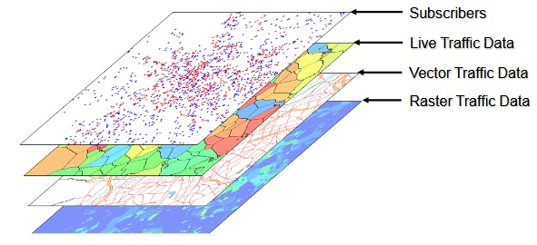
Figure 1. Types of Traffic Data [2].
The following is a summary of the literature review of several journals related to this paper. In the article entitled LTE Radio Planning Using Atoll Radio Planning and Optimization Software (2012), the objective is to determine the coverage area and capacity in Khartoum city. The description is to dimension capacity with Atoll Neighbor Allocation, Frequency Planning, Physical cell ID Planning (Link budget). The outputs are signal quality, diagram coverage by the transmitter, signal levels, coverage areas, and throughput DL/UL [3].
Paper entitled Nominal and Detailed LTE Radio Network Planning considering Future Deployment in Dhaka City (2012) reported that the objectives are to determine total cells and capacity in Dhaka as well basic propagation model using performance analysis. Process RNP are linked to the budget, coverage, and capacity simulation. Nominal Detailed Planning is Propagation Model, Link budget threshold, traffic capacity, planning configuration, survey sites, and eNB parameters selection to determine KPI (Key Performance Indicator). The result used point analysis in Atoll to get the result of Signal level, throughput UL/DL, received power, RSRP, and path loss.
Long Term Evolution Networks Planning Design of Program for Optimization of Next Generation Networks with Focus on LTE (2016) paper gives a summary of essential principals on LTE Planning. Network Planning is divided into Cell sites planning. Coverage Planning consists of determining the location and propagation model. Capacity Planning consists of increasing capacity planning by improving the Network Interference traffic which limited. Frequency Planning consists of choosing the proper bandwidth, and duplexing method depends on requirement [4].
In the paper entitled UMTS vs. LTE Planning by using ATOLL Simulation Tool Case Study Alazhary City Khartoum State Sudan (2015), the objective is to upgrade Alazhary city from UMTS Network (3G) to LTE (4G) by using Atoll. The description of this paper is to determine total sites used, determine max carrier per cell based on frequency reuse and spectrum used, determine cell capacity Comparing UMTS Network Planning and LTE Network Planning LTE increase QoS compared to UMTS by decreasing eNB sites used.
Based on the literature review, this paper aims to determine the maximum subscriber connected for LTE network technology with capacity planning at 1800 MHz FDD for subscriber growth forecasting in 2025 at Denpasar city. The simulation uses Atoll radio network planning software with the Monte Carlo method. This paper is expected to provide benefits for the operator’s telecommunications in determining the right method to find out the number of sites needed for implementation of LTE technology. It is also expected to provide input to the relevant regulators, especially the Ministry of Communication and Information in the determination of frequency for LTE.

Methodology
One of the reasons for choosing the Denpasar City for planning LTE networks is this city has many places for vacation such as the beach and the museums. The interest of this country is felt by residents and tourists. As shown in Figure 3.2, geographically the city of Denpasar has an area of 125,757 km² or 2.18% of the total area of Bali Province. 2,768 hectares of land are rice fields, 10,001 hectares is dry land, and the remaining land area of 9 hectares is for other uses.
Denpasar City is included in urban areas where most of the city is filled with buildings such as hotels, restaurants and shopping centers. Besides that, Denpasar is the seat of government, the center of commerce, education centers, industrial centers and tourist center that consists of 4 districts, namely West Denpasar, East Denpasar, South Denpasar, and North Denpasar [5].
After that, all LTE parameters were defined as Atoll simulation software to create our Network Planning design, the parameters are specification of frequency band, bandwidth, eNBs site, area density, frequency, bandwidth, duplexing method, antenna Half Power Beam Width (HPBW), antenna Electrical Tilt, propagation model and area density as shown in Table 1.
The methodology of capacity planning is shown in Figure 2. Before the capacity planning is calculated, the number of sites in the area is known [6]. Then the data population on 2025 was input with trend population 2005-2025 and traffic profile. After that, the data was simulated with Monte Carlo simulation.

TABLE 1
LTE Network Parameters
LTE Network Parameters | Description
Frequency band | 1800 MHz
Bandwidth | 20 MHz
Duplexing Method | Frequency Division Duplex (FDD)
Antenna Half Power Beam Width (HPBW) | 30°
Antenna Electrical Tilt | 4°
Propagation Model | Cost - Hatta
Area Density | Urban
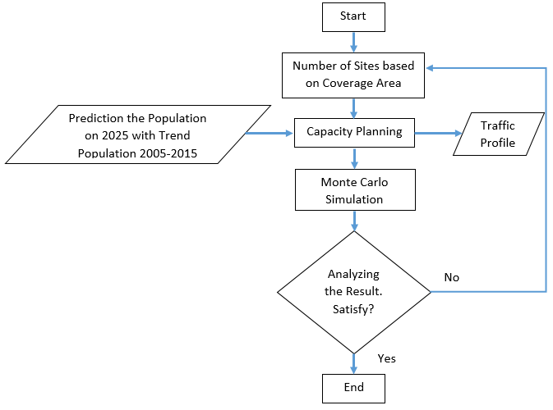
Figure 2. The framework of Capacity Planning.

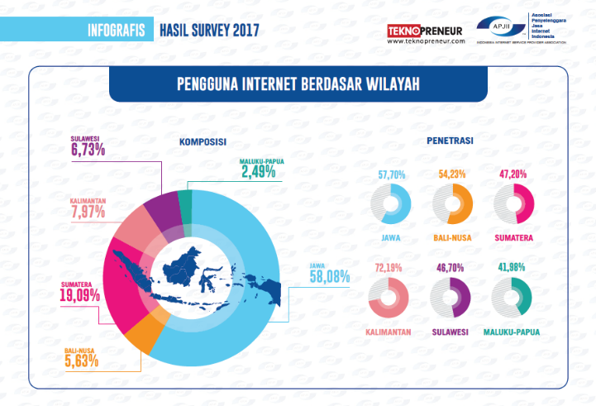
Figure 3. Penetration of Internet Users [7].

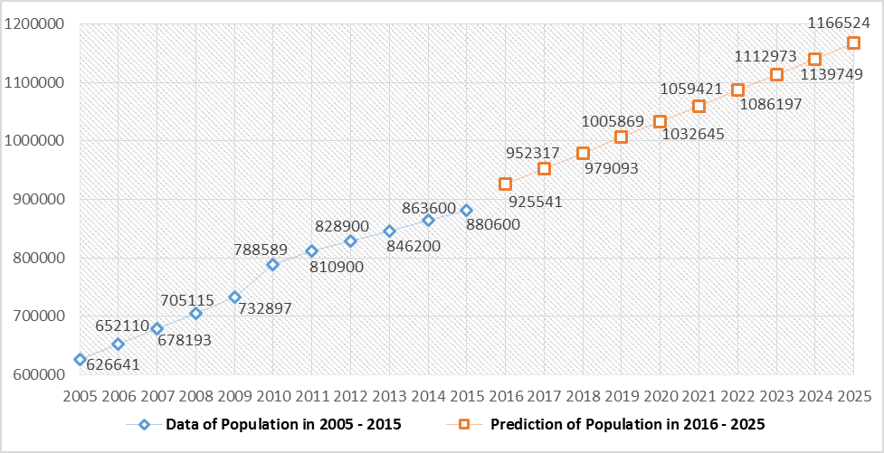
Figure 4. Number of Population at Denpasar City [8].

Figure 3 explains that the growth of internet users in Indonesia has increased every year. It cannot be separated from the technology developed by 3GPP. Starting from 3G technology that supports mobile internet, users can access data quickly, causing more users to access data, so that network quality gradually decreases. Therefore, it is necessary to update technology from 3G to LTE. Furthermore, the optimum planning in determining the number of sites and bandwidth in the network is also needed to be able to survive for a long time.
Based on data from the Indonesian Internet Service Providers Association (APJII), a survey was conducted in 2017 which obtained a penetration composition from internet users in Indonesia as shown in Figure 3. This study used the data based on the penetration of internet users in the Bali-Nusa region at 54.23% to conduct capacity planning in projecting penetration of internet users in Denpasar City. This required data is the projection of prospective customers in 2025 in the city of Denpasar concerning population data from the Central Statistics Agency (BPS) data from 2005 to 2015. Both data are shown in Figure 4.

Results and Discussion
This chapter describes the steps of simulation and data collection that was needed for LTE network design in an urban area using Atoll simulation software. The simulation is implemented to get the optimal number of sites to cover the area and results of capacity for a long time.

- LTE Network Parameters
As shown in Table 2, this study used the E-UTRA band frequency band 3 - 20 MHz with the duplexing method criteria is FDD at 1800 MHz frequency and 20 MHz bandwidth.
- Propagation Model
The application of this propagation model is used as one of the parameters in the link budget to calculate radius coverage [9]. As explained in the previous chapter, the selection of Cost-231 Hata was considered suitable to be applied on the 1800 MHz frequency.
- Simulation of Capacity Planning
To do capacity planning, user traffic profiles are needed as an assumption to yield high-speed internet, mobile internet access, video conferencing and voice. Based on the existing data, this research compared the composition in 2017 and forecasting in 2025 with four types of services as shown in Table 3. The service was simulated to show the result of how many users connected and how many users rejected.
After determining the user profile, the following parameter of traffic is to create traffic maps per density. This traffic map was used in the following Monte Carlo simulation as shown in Figure 5. This simulation aims to find out the user profile environment in Denpasar City based on the clutter class. Before performing a Monte Carlo simulation, it is necessary to input the parameters in the urban properties. Figure 6 and 7 shows the conditions of clutter weight in 2017 and 2025.
The final stage of the capacity planning simulation using Monte Carlo is knowing the number of customers who can connect with the network, the number of rejected customers, customers who are not covered, no service or inactive.

TABLE 2
List Frequency Band in Atoll.
Name | Duplexing Method | TDD: Start Frequency,  FDD: DL Start Frequency (MHz) | FDD: DL Start Frequency (MHz) | Channel Width (MHz) | Inter-Channel spacing (MHz) | Number of Frequency Blocks
E-Utra Band1 - 10 MHz | FDD | 2110 | 1920 | 10 | 0 | 50
E-Utra Band1 - 15 MHz | FDD | 2110 | 1920 | 15 | 0 | 75
E-Utra Band1 - 20 MHz | FDD | 2110 | 1920 | 20 | 0 | 100
E-Utra Band1 - 5 MHz | FDD | 2110 | 1920 | 5 | 0 | 25
E-Utra Band12 - 10 MHz | FDD | 729 | 699 | 10 | 0 | 50
E-Utra Band12 - 5 MHz | FDD | 729 | 699 | 5 | 0 | 25
E-Utra Band3 - 10 MHz | FDD | 1805 | 1710 | 10 | 0 | 50
E-Utra Band3 - 15 MHz | FDD | 1805 | 1710 | 15 | 0 | 75
E-Utra Band3 - 20 MHz | FDD | 1805 | 1710 | 20 | 0 | 100
E-Utra Band3 - 5 MHz | FDD | 1805 | 1710 | 5 | 0 | 25

TABLE 3
Characteristics of LTE Users in 2017 and 2025
Service | Calls/hour | UL Volume (Kbytes) |  | DL Volume (Kbytes)
Service | Calls/hour | 2017 | 2025 | 2017 | 2025
High-Speed Internet | 0.05 | 700 | 2.000 | 15.000 | 4.500
Mobile Internet Access | 0.1 | 100 | 700 | 4.500 | 100
Video Conference | 0.01 | 5.000 | 10.000 | 10.000 | 5.000
Voice | 0.2 | 250 | 500 | 500 | 250

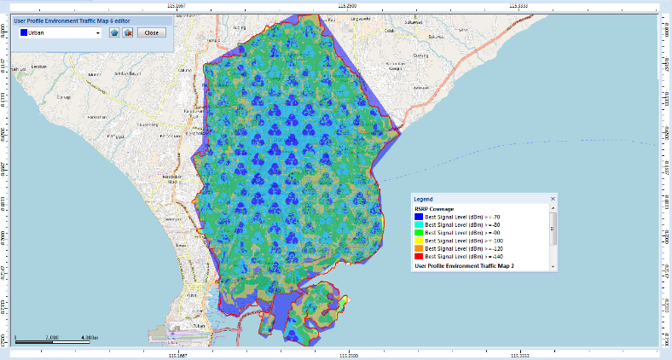
Figure 5. User Profile Environment.
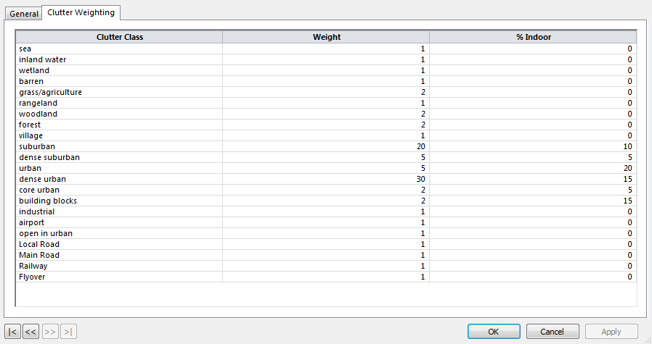
Figure 6. Urban Properties in 2017.
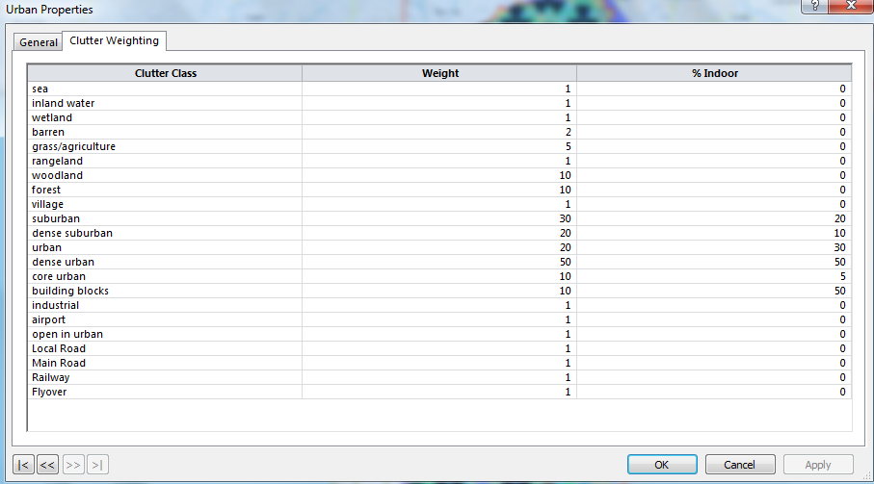
Figure 7. Urban Properties in 2025.
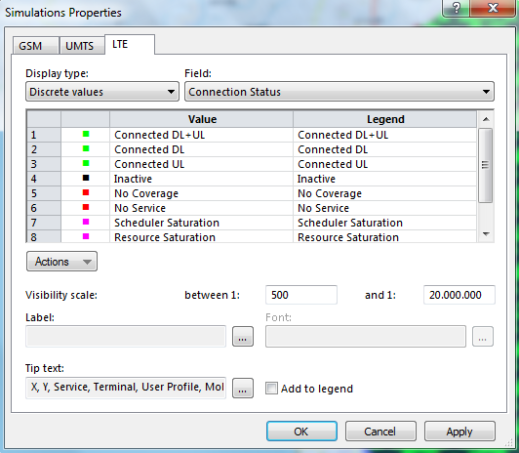
Figure 8. Simulation Properties.
Figure 9 and Figure 10 are the results obtained from capacity planning using Monte Carlo Simulation in 2017 and 2025. The number of sites used 129 sites. Figure 11 showed the number of requests users trying to connect to this simulation in 2025 with the total of 4,834 users which 2,544 users to downlink, 1,211 users to uplink, 474 users to downlink and uplink, and 605 users inactive. The maximum downlink demand throughput 706.12 Mbps and the maximum uplink demand throughput 116.48 Mbps. Meanwhile, the minimum downlink demand throughput 229.6 Mbps and the minimum uplink demand throughput 55.07 Mbps.
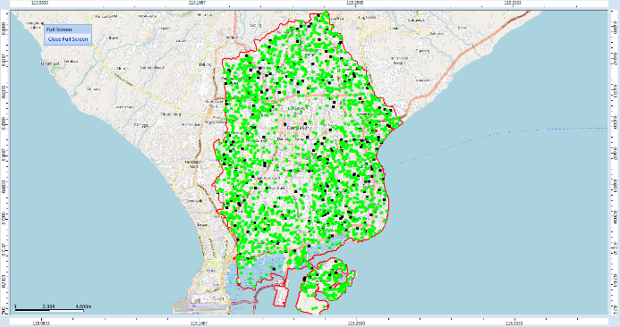
Figure 9. The result of Capacity Dimensioning using Monte Carlo Simulation in 2017.
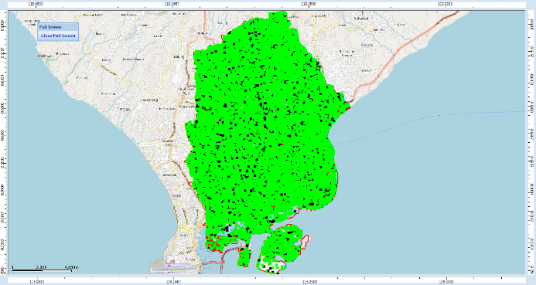
Figure 10. The result of Capacity Dimensioning using Monte Carlo Simulation in 2025.
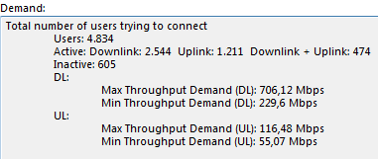

Figure 11. Total Number of Users trying to Connect in 2025.

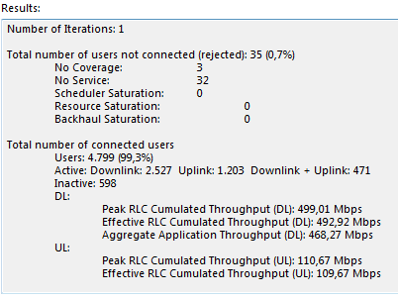
Figure 12. The result of Monte Carlo Simulation in 2025.

In Figure 12, the total number of requests is 4,834 users, with the total number of users not connected or rejected is 0.7% users or 35 users are not served. However, 4,799 users or 99.3% of the total number of connected users can be connected.

Conclusion

The result of capacity planning using the Monte Carlo simulation shows that 129 sites still good in 2017 and 2025. In 2017, from the total of 2,447 users who tried to connect, 99.8% or 2,442 users were successfully connected, and only 0.2% or 5 users were rejected. While in 2025, from the total of 4,834 users who tried to connect, 99.3% or 4,799 users were successfully connected and only 0.7% or 35 users were rejected.

Acknowledgement
This research was conducted with the support from the Higher Education Kopertis Region III, LP2M Al Azhar University, and the Electrical Engineering Laboratory of the Faculty of Science and Technology, University of Al Azhar Indonesia.

References

