Subscriber Growth Forecasting of LTE Network 1800 MHz FDD in 2025 at Denpasar City using Monte Carlo Simulation

Suci Rahmatiaª, Azmi Azizah Azzahra, Muhammad Ismail, Dwi Astharini, Octarina Nur Samijayani
ªElectrical Engineering
Faculty of Science and Technology University of Al Azhar Indonesia
Jl. Sisingamangaraja Kebayoran Baru
Jakarta Selatan, Indonesia

Corresponding_suci@uai.ac.id, rafiftsaqif2010@gmail.com, azmi.azizah.azzahra@gmail.com, astharini@uai.ac.id, octarina.nur@uai.ac.id

Abstract
LTE is a release 8 technology developed by 3rd Generation Partnership Project (3GPP). LTE technology is a solution that used by engineers to resolve the problems of improving the quality of communications services. LTE can delivered speeds of downlink up to 300 Mbps and uplink 75 Mbps. This paper aims to determine the maximum subsciber connected for LTE network technology with capacity planning at 1800 MHz Frequency Division Multiplexing for subscriber growth forecasting in 2025 at Denpasar city. The simulation using Atoll radio network planning software using Monte Carlo method. Monte Carlo are used to investigate the increase user throughput according to customer distribution, path loss and services provided. This simulation is based on traffic data from traffic maps, lists of subscribers and user penetration and cellular services. Monte Carlo simulation shows the results in 2017 of 99.8% of users are successfully connected and only 0.2% were rejected. For forecasting in 2025, 99,3% of users are successfully connected and only 0.7% were rejected.

Keywords : LTE Nework, Frequency Division Multiplexing, Capacity Planning, Monte Carlo Simulation

Introduction
Theoretical capacity of the network is limited by the number of eNodeB’s installed in the network. At a certain level of quality of service (QoS) such as throughput or probability of users being received or blocked, it is necessary to have capacity planning. Factors that affect capacity in a cell include the level of interference, supporting modulation, and coding schemes. Link budget calculations in coverage planning previously provided the maximum allowed path loss and maximum range of the cells. In LTE network, the main indicator of capacity is the SINR distribution in the cell. In order to be able to get an optimal capacity planning, it is necessary to estimate the appropriate of throughput cell to decrease the cell radius and the need for traffic analysis to obtain traffic requests such as number of customers, mix of traffic and data about the geographical distribution of customers in the distribution area. [1]
A capacity planning analysis requires a Monte Carlo simulation. This simulation also aims to test reliability in previous simulations, namely predictive coverage simulation. Monte Carlo simulation is used to increase user throughput according to customer distribution, path loss and services provided. This simulation is based on traffic data from traffic maps, lists of subscribers and user penetration and cellular services.
As shown in Figure 1, there are several types of traffic from traffic maps on Monte Carlo simulations, namely: raster traffic maps, vector traffic maps, live traffic maps, and traffic density maps. Raster Traffic Map, this can be used if you have traffic data directly from OMC (Operation and Maintenance Center). OMC collects data from all cells in the network. For example, the number of users or throughput in each cell and different contents with different services. Traffic is spread in the best server area of each transmitter and every area provided through throughput and downlink or the number of users per activity status.

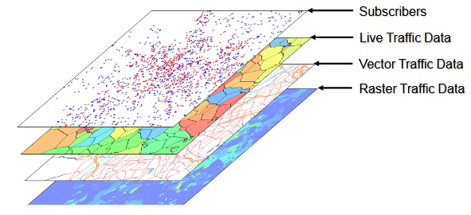
Figure 1. Types of Traffic Data [2]
Vector Traffic Maps, where each vector (polygon, line or point) describes the density of the customer (or number of customers to point) with the user profile and type of mobility, and the map of traffic per user profile environment, where each pixel has an assigned environmental class. Live Traffic Maps, this can be used if you have marketing-based traffic data. Traffic Density Maps, traffic maps that use traffic data based on the region of population and each pixel has an actual user density set.
The following is a summary of the literature review of several journals related to this paper. LTE Radio Planning Using Atoll Radio Planning and Optimization Software, 2012. The objective is to determine the coverage area and capacity in Khartoum city. The description is to dimensioning capacity with Atoll Neighbor Allocation, Frequency Planning, Physical cell ID Planning (Link budget). The output are signal Quality, diagram coverage by transmitter, signal levels, coverage areas, and throughput DL/UL.
Nominal and Detailed LTE Radio Network Planning considering Future Deployment in Dhaka City, 2012. The objectives are to determine total cells and capacity in Dhaka as well basic propagation model using performance analysis. Process RNP are link budget, coverage and capacity simulation. Nominal Detailed Planning are Propagation Model, Link budget threshold, traffic capacity, planning configuration, survey sites, and eNB parameters selecting. Determine KPI (Key Performance Indicator). The result using point analysis in Atoll to get result of Signal level, throughput UL/DL, received power, RSRP, and path loss.
Long Term Evolution Networks Planning Design of Program for Optimization of Next Generation Networks with Focus on LTE, 2016. Give a summary about important principals on LTE Planning. Network Planning is divided into Cell sites planning. Coverage Planning consists of determine location and propagation model. Capacity Planning consists of increasing capacity planning by improving the Network Interference traffic which limited. Frequency Planning consists of choosing proper bandwidth and duplexing method depend on requirement.
UMTS vs LTE Planning by using ATOLL Simulation Tool Case Study Alazhary City Khartoum State Sudan, 2015. The objective is to upgrade Alazhary city from UMTS Network (3G) to LTE (4G) by using Atoll. The description of this paper are to determine total sites used, determine max carrier per cell based on frequency reuse and spectrum used, determine cell capacity Comparing UMTS Network Planning and LTE Network Planning LTE increase QoS compared to UMTS by decreasing eNB sites used.
Based on the literature review, this paper aims to determine the maximum subsciber connected for LTE network technology with capacity planning at 1800 MHz FDD for subscriber growth forecasting in 2025 at Denpasar city. The simulation using Atoll radio network planning software using Monte Carlo method. This paper is expected to provide benefits for operator’s telecommunications in determining the right method to find out the number of sites needed for implementation LTE technology. It is also expected to provide input to the relevant Regulators, especially the Ministry of Communication and Information determination of frequency for LTE.

Method
One of the reasons choosing the Denpasar City for planning LTE networks is because this city has many places for vacation such as the beach and the museums. The interest of this country is not only felt by local residents but also tourists. As shown in Figure 3.2, Geographically the city of Denpasar has an area of 125,757 km² or 2.18% of the total area of the total area of Bali Province. From the use of land, 2768 hectares of land are rice fields, 10,001 hectares is dry land and the remaining land area of 9 hectares is for other uses.
Denpasar City is included in urban areas where most of the city is filled with buildings such as hotels, restaurants and shopping centers. Besides that, Denpasar is the seat of government, the center of commerce, education centers, industrial centers and tourist center that consists of 4 districts, namely West Denpasar, East Denpasar, South Denpasar, and North Denpasar. [3]
After that, define all LTE parameters into Atoll simulation software to create our Network Planning design, the parameters are specification of frequency band, bandwidth, eNBs site, area density, frequency, bandwidth, duplexing method, antenna Half Power Beam Width (HPBW), antenna Electrical Tilt, propagation model and area density as shown in Table 1 below.

TABLE 1
LTE Network Parameters
LTE Network Parameters | Description
Frequency band | 1800 MHz
Bandwidth | 20 MHz
Duplexing Method | Frequency Division Duplex (FDD)
Antenna Half Power Beam Width (HPBW) | 30°
Antenna Electrical Tilt | 4°
Propagation Model | Cost - Hatta
Area Density | Urban

The methodology of capacity planning is shown in Figure 2. Before the capacity planning is calculated, the number of sites in the area is known. Then input the data population on 2025 with trend population 2005-2025 and traffic profile. After that simulate the data with Monte Carlo simulation.

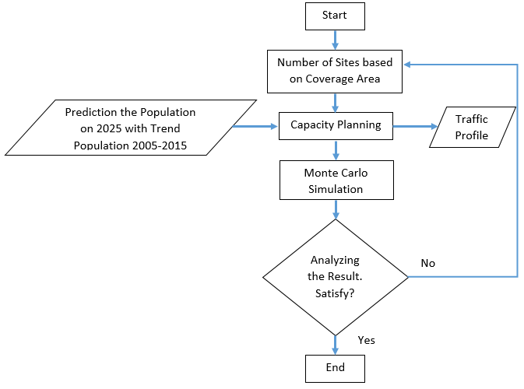
Figure 2. Framework of Capacity Planning
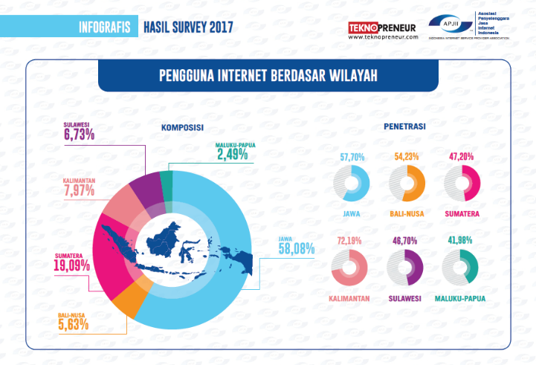
Figure 3. Penetration of Internet Users [4]
Figure 3 explain the growth of internet users in Indonesia has increased every year. This cannot be separated from the technology developed by 3GPP. Starting from 3G technology that supports mobile internet users to be able to access data easily, causing more users to access data so that network quality will decrease. Therefore, it is necessary to update technology from 3G to LTE. Not only that, the optimum planning in determining the number of sites and bandwidth in the network is also needed to be able to survive for a long time.
Based on data from the Indonesian Internet Service Providers Association (APJII), a survey was conducted in 2017, which obtained a penetration composition from internet users in Indonesia as shown in Figure 3.4. To conduct capacity planning in this study projecting penetration of internet users in Denpasar City based on penetration of internet users in the Bali-Nusa region at 54.23%.
The data that is needed next is the projection of prospective customers in 2025 in the city of Denpasar with reference to population data from the Central Statistics Agency (BPS) data from 2005 to 2015. Both data are shown in this graph Figure 4.

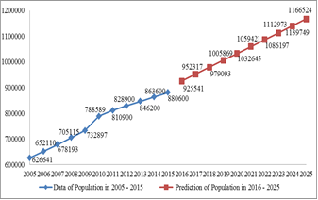
Figure 4. Number of Population at Denpasar City [5]

Results and Discussion
This chapter describes steps of simulation and data collection that needed for LTE network design in urban area using Atoll simulation software. The simulation are implemented to get the optimal number of sites to cover the area and results of capacity for a long time.
LTE Network Parameters
As shown in Table 3 below, this study used the E-UTRA band frequency band 3 - 20 MHz with the duplexing method criteria is FDD at 1800 MHz frequency and 20 MHz bandwidth.

TABLE 2.
List Frequency Band in Atoll
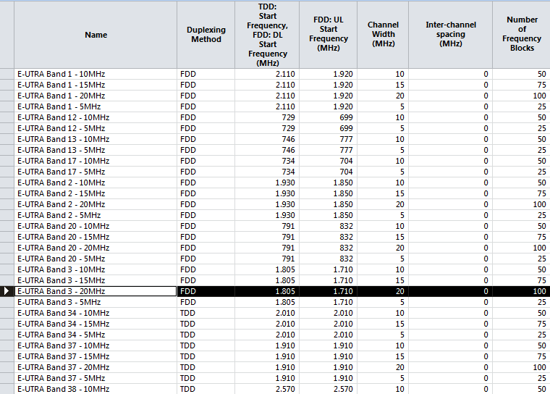

Propagation Model
The application of this propagation model is used as one of the parameters in the link budget to calculate radius coverage. As explained in the previous chapter, the selection of Cost-231 Hata was considered suitable to be applied on the 1800 MHz frequency that was chosen in this study.
Simulation of Capacity Planning
To do capacity planning, user traffic profiles are needed which are assumed to be high speed internet, mobile internet access, video conferencing and voice. Based on the data which are owned, this research comparing the composition in 2017 and forecasting in 2025 with these 4 types of services as shown in Table 3. The service will be simulated to show the result how many users connected and how many are rejected.

TABLE 3.
Characteristics of LTE Users in 2017 dan 2025
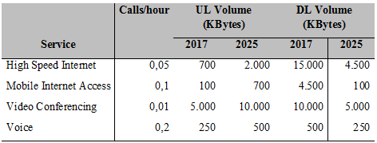

After determining the user profile, the next parameter traffic is to create traffic maps per density. This traffic map will be used in the following Monte Carlo simulation. As shown in Figure 5.

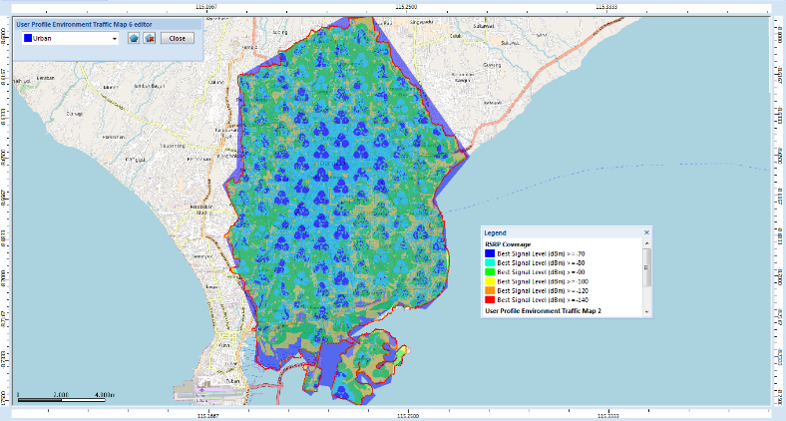
Figure 5. User Profile Environment
The aim is to find out the user profile environment in Denpasar City based on the clutter class. Before performing a monte carlo simulation, it is necessary to input the parameters in the urban properties. Figure 6 and 7 shows the conditions of clutter weight in 2017 and 2025.

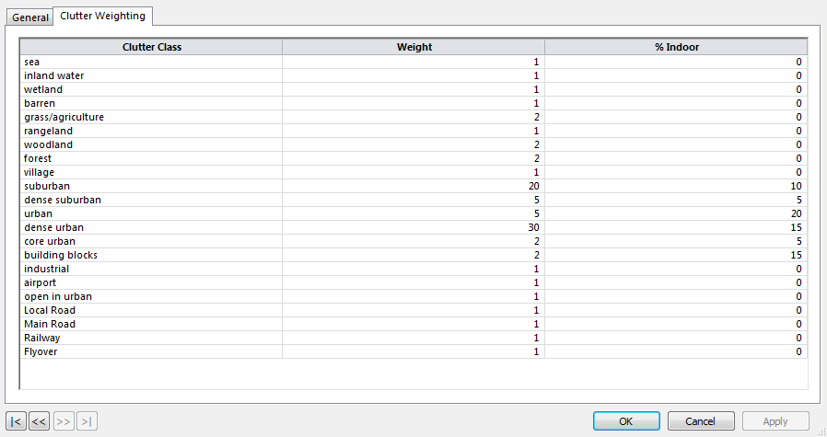
Figure 6 Urban Properties in 2017
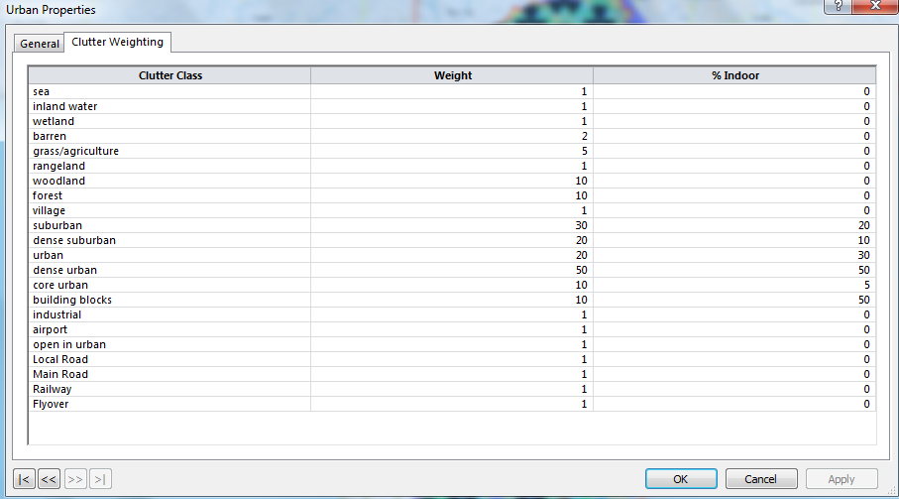
Figure 7 Urban Properties in 2025

The final stage of the capacity planning simulation using monte carlo is knowing the number of customers who can connect with the network, the number of rejected customers, who are not covered, no service or inactive.

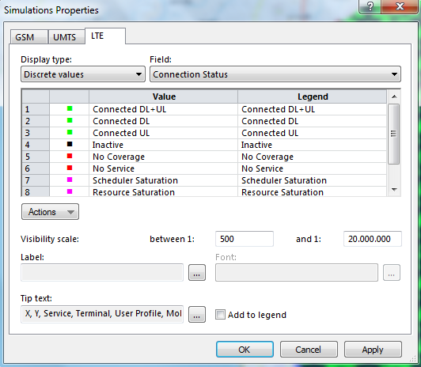
Figure 8. Simulation Properties
Figure 9 and Figure 10 is the result obtained from capacity planning using Monte Carlo Simulation in 2017 and 2025. The number of sites used as many as 129 sites.

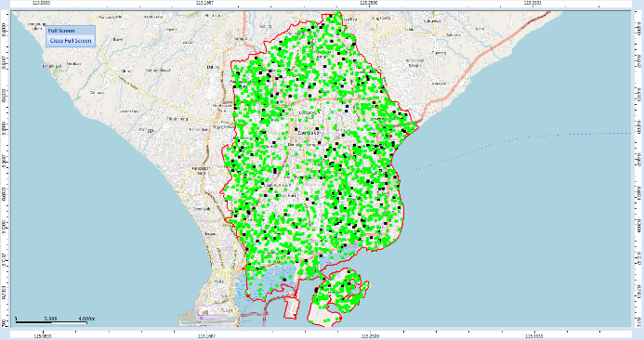
Figure 9. Result of Capacity Dimensioning using Monte Carlo Simulation in 2017
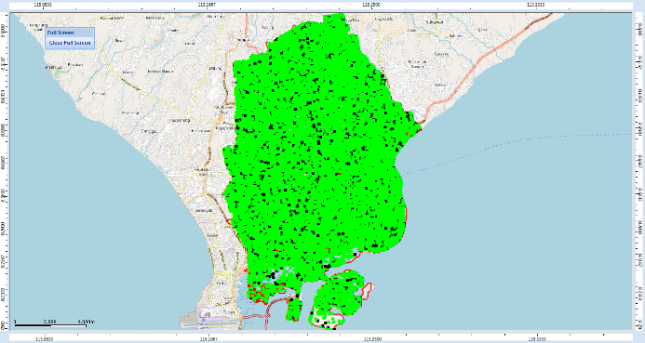
Figure 10. Result of Capacity Dimensioning using Monte Carlo Simulation in 2025
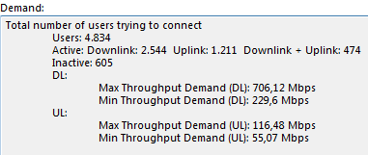
Figure 11. Total Number of Users trying to Connect in 2025
Figure 11 shown the number of requests users try to connect to this simulation in 2025 as many as 4834 users with 2544 users to downlink, 1211 users to uplink, 474 users to downlink and uplink, and 605 users inactive. Where the maximum downlink demand throughput is 706.12 Mbps and the maximum uplink demand in the uplink is 116.48 Mbps. While the minimum demand throughput is at 229.6 Mbps downlink and the minimum uplink demand throughput is 55.07 Mbps.

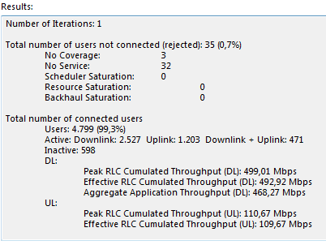
Figure 12. Result of Monte Carlo Simulation in 2025
From the result of monte carlo simulation can be seen in 2025.

In Figure 12, the total number of requests as many as 4834 users, obtained the total number of users not connecter or rejected there are 0.7% users or 35 users are not served. However, as many as 4799 users or 99.3% of the total number of connected users can be connected.

Conclusion
The results of capacity planning using the Monte Carlo simulation shows with 129 sites still good in 2017 and 2025. In 2017, from 2447 users who tried to connect, 99.8% or 2442 users were successfully connected and only 0.2% or as many as 5 users were rejected. While in 2025, from 4834 users who tried to connect, 99.3% or 4799 users were successfully connected and only 0.7% or as many as 35 users were rejected.

Acknowledgment
This research was conducted with the support of the Higher Education Kopertis Region III, LP2M Al Azhar University, and the Electrical Engineering Laboratory of the Faculty of Science and Technology, University of Al Azhar Indonesia.

References
- A. B. Syed, “Dimensioning of LTE Network. Description of Models and Tool, Coverage and Capacity Estimation of 3GPP Long Term Evolution Radio Interface”, Masters Thesis submitted in partial fulfillment of the requirements for the Degree of Masters of Science in Technology, Helsinki University of Technology, 2009.
- Atoll, in Atoll.3.2.1.5838.Portable.MxBNET, Forsk, 2011.
- Bali Gory, “Denpasar: The Capital City (Kota) of Bali”, www.denpasarkota.go.id[online].Available:http://www.baliglory.com/2013/04/kota-denpasar-city-bali-capital.html, [Accessed Juni 20, 2018]
- Asosiasi Penyelenggara Jasa Internet Indonesia (APJII), Infografis : PENETRASI & PERILAKU PENGGUNA INTERNET INDONESIA, survey, 2017.
- Badan Pusat Statistik, “Jumlah dan Laju Pertumbuhan Penduduk Kota Denpasar, 2001-2015,” Denpasar : 2015.
- S. Pranoto, May 8 2015. Teknologi 4G LTE : Coverage Planning [Online]. Avaliable: http://teknologi-4g-lte.blogspot.com/2015/05/coverage-planning.html. [Accessed Juny 30, 2018].
- Y. Septiawan, I. Santoso, dan A. Ajulian,“Perencanaan Jaringan Long Term Evolution (LTE) Time Division Duplex (TDD) 2300 MHz di Semarang Tahun 2015 – 2020”, Jurusan Teknik Elektro, Universitas Diponegoro Semarang, 2014.
- M. A. Syiaruddin and L. O. Sari, “Optimisasi Perencanaan Jaringan LTE FDD 1800 MHz di Kota Pekanbaru”, Jom FTEKNIK Volume 4 No.2 Oktober 2017, 2017.

