Fabrication of Hybrid Polymer Solar Cells By Inverted Structure Based on P3HT:PCBM Active Layer
Pembuatan Sel Surya Polimer Hibrida dengan Susunan Terbalik Berbasis Lapisan Aktif P3HT: PCBM
Shobih ^{a, *}, Rizky Abdillah ^{b}, Erlyta Septa Rosa ª
ª Pusat Penelitian Elektronika dan Telekomunikasi, Lembaga Ilmu Pengetahuan Indonesia.
Komp. LIPI Gd 20, Jl Sangkuriang 21/54D, Bandung 40135, Indonesia
^{b} Physical Engineering, Faculty of Technology,
Telkom University, Terusan Buah Batu Bandung 40257 Indonesia

Abstract
Hybrid polymer solar cell has privilege than its conventional structure, where it usually has structure of ITO/PEDOT:PSS/Active Layer/Al. In humid environment the PEDOT:PSS will absorb water and hence can easily etch the ITO. Therefore it is necessary to use an alternative method to avoid this drawback and obtain more stable polymer solar cells, namely by using hybrid polymer solar cells structure with an inverted device architecture from the conventional, that is by reversing the nature of charge collection. In this paper we report the results of the fabrication of inverted bulk heterojunction polymer solar cells based on P3HT:PCBM as active layer, utilizing ZnO interlayer as buffer layer between the ITO and active layer with a stacked structure of ITO/ZnO/P3HT:PCBM/PEDOT:PSS/Ag. The ZnO interlayer is formed through short route, i.e. by dissolving ZnO nanoparticles powder in chloroform-methanol solvent blend rather than by sol-gel process. Based on the measurement results on electrical characteristics of inverted polymer solar cells under 500 W/m² illumination and AM 1.5 direct filter at room temperature, cell with annealing process of active layer at 110 °C for 10 minutes results in higher cell performance than without annealing, with an open-circuit voltage of 0.21 volt, a short-circuit current density of 1.33 mA/cm², a fill factor of 43.1%, and a power conversion efficiency of 0.22%. The low cell’s performance is caused by the very rough surface of the ZnO interlayer.

Keywords: inverted polymer solar cells, P3HT, PCBM, PEDOT:PSS, ZnO interlayer.

Abstrak
Sel surya polimer hibrida mempunyai keistimewaan jika dibandingkan dengan sel surya polimer konvensional. Sel surya polimer konvensional biasanya mempunyai struktur ITO/PEDOT:PSS/Lapisan Aktif/Al. Pada lingkungan yang lembab, PEDOT:PSS akan menyerap air yang selanjutnya akan mengetsa lapisan ITO. Oleh karena itu diperlukan metode lain untuk mengatasi hal ini sehingga didapatkan sel surya polimer yang lebih stabil, yakni dengan menggunakan arsitektur divais terbalik dari sel surya polimer konvensional, yaitu dengan membalik sifat pengumpulan muatannya. Tulisan ini melaporkan hasil penelitian mengenai pembuatan sel surya polimer bulk heterojunction inversi berbasis P3HT:PCBM sebagai lapisan aktif, menggunakan interlayer ZnO sebagai lapisan penyangga antara ITO dan lapisan aktif dengan susunan bertumpuk ITO/ZnO/P3HT:PCBM/PEDOT:PSS/Ag. Interlayer ZnO dibuat melalui rute yang singkat, yakni dengan melarutkan serbuk partikel nano ZnO ke dalam campuran pelarut metanol-kloroform, selain dengan cara proses sol-gel. Berdasarkan hasil pengukuran karakteristik listrik dari sel surya polimer inversi di bawah penyinaran 500 W/m² dan filter AM 1.5 direct pada suhu ruangan, sel dengan proses anil lapisan aktif pada 110 °C selama 10 menit menghasilkan kinerja sel yang lebih tinggi daripada sel yang tidak dianil, dengan tegangan sirkuit terbuka sebesar 0,21 volt, densitas arus hubung singkat sebesar 1,33 mA/cm², fill factor sebesar 43,1%, dan efisiensi konversi daya sebesar 0,22%. Rendahnya kinerja sel ini disebabkan oleh permukaan interlayer ZnO yang sangat kasar.

Kata kunci: sel surya polimer susunan terbalik, P3HT, PCBM, PEDOT:PSS, antar lapis ZnO.

Introduction
Efficiency, lifetime, and costs (per Wp) are the main factors that determine the competitive position of every solar technology in the energy market, so all these requirements have to be fulfilled simultaneously by the technology in order to dominate the niche market [1]. Polymer or organic materials are usually processed in solution conditions and have high absorptivity [2] as well, thus allowing the polymer solar cell devices (PSCs) can be produced on a large scale area and in thin layer (nanoscales) dimension [3], [4]. These will result in reducing the production costs. If the price is reduced significantly, a slightly lower efficiency or durability of the devices seem to be acceptable. Therefore, PSCs to be considered as a main candidate for low-cost solar-energy conversion applications although they still have low power conversion efficiency (PCE) compared to silicon solar cells, which still dominate photovoltaic market.
* Corresponding Author.
Email: shobih@gmail.com
Received: July 14, 2017 ; Revised: August 18, 2017
Accepted: August 21, 2017 ; Published: August 31, 2017
© 2017 PPET - LIPI All rights reserved
25-32

Currently, all efficient PSCs are based on bulk heterojunctions (BHJs) where electron-donor (p-type) and electron acceptor (n-type) materials are intimately mixed to form junctions throughout the bulk. The junctions contain a nanoscale interpenetrating network of electron donor and electron acceptor materials with bi-continuous phase separation. This morphology enhances interfacial area where the photo-generated excitons are dissociated into charge carriers and enables holes and electrons to be collected and transported to the respective electrodes [5].
At present [6,6]-phenyl-C₆₁-butyric acid methyl ester (PC₆₀BM) and its corresponding C₇₀ derivative PC₇₀BM are dominantly used as the electron acceptors in PSCs, due to their high electron affinity and outstanding n-type mobility [6]. Whereas, poly(phenylene vinylene)s (PPVs) and polythiophenes (PTs) are two kinds of classic conjugated polymers which are generally used as electron-donor. Poly(2-methoxy-5-(2’-ethylhexyloxy)-p-phenylene vinylene) (MEH-PPV) and poly (2-methoxy-5-(3’,7’-dimethyloctyloxy)-1,4-phenylene-vinylene (MDMO-PPV) are two representatives of PPV-based materials. They exhibited much similar photovoltaic properties [7]. PCE of 2 to 3% has been recorded by using MEH-PPV/PCBM and MDMO-PPV/PCBM [8] based solar cells. Poly(3-hexylthiophene) (P3HT) is one of the derivatives of PTs that has lower band gap, broader absorption band and also better hole mobility, therefore, this conjugated polymer exhibited much better photovoltaic properties. P3HT/PCBM based solar cells has achieved PCE of 4-5 % [9]. By using new polymers, PCE of more than 7% has been reached [10].
The overall device architecture for conventional PSCs which have been mentioned before usually have structure of ITO/PEDOT:PSS/Active Layer/Al. In this structure, indium tin oxide (ITO) coated glass serves as the anode and a low-work-function, Al as the cathode. Active layer is a mixture of electron-donor conjugated polymer and electron acceptor material. PEDOT:PSS, which stands for poly(3,4-ethylenedioxythiophene): poly(styrenesulfonate) is frequently used as a hole transport material where it functions as an anode interfacial layer for improving the collection of holes, as well as to improve the anode contact. If it is used as an anode interfacial layer, due to its hygroscopic and highly acidic nature, it will degrade the PSC’s performance. In humid environment it will absorb water and hence can easily etch the ITO [11] – [13]. Therefore, it is necessary to use an alternative method to avoid this drawback such as utilizing n-type metal oxide materials as interlayer to obtain more stable PSCs, namely by using an inverted device architecture from the conventional, by reversing the characteristic of charge collection. By using the inverted structure, the interface of ITO/PEDOT:PSS can be evaded and enable to utilize the air-stable, high-work-function metals such as Au and Ag instead of the air-sensitive, low-work function Al [14].
In this paper we report the results of the fabrication of inverted bulk heterojunction PSCs based on P3HT:PCBM as active layer, utilizing ZnO interlayer as buffer layer between the ITO and active layer with a stacked structure of ITO/ZnO/P3HT:PCBM/ PEDOT:PSS/Ag. ZnO which is an n-type metal oxide used as interlayer because it has good transparency across the whole visible spectral range, relatively high electron mobility, and environmental stability. Many researchers have implemented ZnO interlayer films synthesized through sol-gel routes in inverted bulk heterojunction PSCs with significant PCE [14], [15]. Herein, the film is formed through short route, i.e. by dissolving ZnO nanoparticles powder in chloroform-methanol solvent blend rather than by sol-gel process. We also study the influences of active layer thermal annealing on optical and electrical characteristics of the inverted PSCs, considering that thermal treatment is very influential on morphology and chain regularity of polymer substances used as an active layer, which will then determine the performance of the cells.

Experimental
To avoid short circuit between cathode and anode, it is necessary the ITO coated glass substrates (Sigma Aldrich, 12 Ω/sq) to be patterned. Adhesive tape was attached on the undesired ITO layer with guidance of ITO Mask as presented in Figure 1, and then aerosol paint was sprayed onto uncovered ITO surface. After the paint layer had dried, adhesive tape was released from the substrates. The substrates were then immersed in 50% HCl (Merck, 37%) in deionized (DI) H₂O solution to etch the uncovered ITO for 5 minutes, and then rinsed with DI H₂O and dried. The substrates then immersed into thinner solution and acetone consecutively for 10 minutes in ultrasonic bath to remove the paint layer.
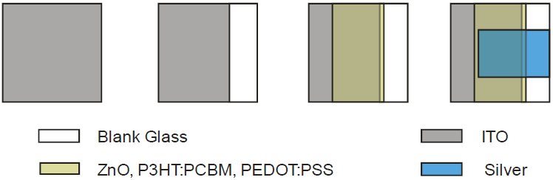
Figure 1. Mask Patterns for Respective Layers in Inverted Polymer Solar Cells.
Before depositing ZnO layer, the patterned ITO substrates were cleaned by immersing them into detergent-containing DI H₂O, DI H₂O, and isopropyl alcohol (2-propanol, Merck) for 10 minutes consecutively in ultrasonic bath. After drying, the patterned ITO substrates were attached by adhesive Schott tape as masker to restrict the ZnO, active layer and PEDOT: PSS areas. ZnO nanoparticles solution was then deposited onto ITO surface by spin coating technique. ZnO solution was made by dissolving ZnO nanoparticles (Sigma Aldrich) powder in chloroform (Merck)-methanol (Merck) solution (2:1 ratio) and mixing with magnetic stirrer overnight. ZnO layer thickness is set by adjusting the spin speed of 1500 rpm for 30 seconds [16]. The substrates were then heated in a vacuum dryer for 20 minutes at a temperature of 80 ℃
The active layer used in this study was a mixture of P3HT (Sigma Aldrich) and PCBM (Sigma Aldrich) with a ratio of 1:1 in chlorobenzene solvent. According to previous researches in [17], [18], this ratio gives the best PSCs performance. Before deposited onto ZnO layer, polymer mixture with a concentration of 2%, was mixed overnight using a magnetic stirrer until the mixture perfectly dissolved. The polymer mixture was then deposited by spin coating technique at 600 rpm for 60 seconds [9]. The active layer was left for 30 minutes in a nitrogen environment, some substrates were annealed in vacuum oven at temperature of 110 ℃ for 10 minutes to study the effect of the process on their optical and electrical properties.
PEDOT:PSS (Sigma Aldrich) used as a hole transport materials, was deposited onto active layer by spin coating technique at 1500 rpm for 30 seconds. PEDOT:PSS layer then annealed in a vacuum oven at 100 ℃ for 20 minutes. Before coated with silver (Ag) as cathode, all the attached adhesive tapes on the substrates were released. Ag was coated onto PEDOT:PSS surface through a shadow mask by evaporation technique. Ag wire (Sigma Aldrich) was evaporated in Edwards Auto 306 evaporator system under vacuum condition of 2×10⁻⁵ mBar with thickness of 38 nm. The cell’s active area obtained was around 0.30 cm². Figure 2 shows the structure of the inverted polymer solar cell.
Figure 2. The Structure of The Fabricated Inverted Polymer Solar Cells.
The final process was lamination, to protect the cells from the outside air and moisture. Before laminated, two tabbing wires with 15 mm long were attached to respective electrodes using Ag paste glue as the external contacts for I-V characterization and incident photon-to-current conversion efficiency (IPCE) measurement. Lamination process was performed by attaching thermoplastic sealant (DuPontTM Surlyn®) between devices and PETs, and then clamped using two glasses on both sides. After that, they were heated in vacuum oven at 100℃ for 10 minutes.
Absorption spectra of active layers were obtained by spin coating of P3HT:PCBM blend onto preparation glass substrates, and the thin films spectra were obtained from UV–Visible spectrophotometer. Surface morphology of ZnO layer was observed by scanning electron microscope (SEM).
The fabricated solar cells were characterized using Oriel Solar simulator under 500 W/m² and AM 1.5 direct filter illumination which equipped with computer-controlled National Instrument SMU 3140 to measure current-voltage characteristics. The IPCE of the cells were characterized by IPCE measurement system in DC mode from PV-Measurement. Important to note, that the entire process of the PSCs fabrication and their characterizations are performed in an ambient environment conditions, except as specified under certain condition.

Results and Discussion
Figure 3 shows the absorbance of active layer with and without thermal annealing process. As indicated by the figure, the longest absorption wavelength of the spectra are located at around 650 nm. Like other organic polymers which have a wide band gap, PH3T:PCBM blends with 1:1 ratio as an active layer give an efficient absorption at near UV part. At this ratio, the band gap of the blends are approximately or less than 1.9 eV (PH3T band gap) [19]. The absorbance spectrum of the active layer is the unification of the absorbance of pristine PCBM and of pristine P3HT. At the wavelength around 514 nm is P3HT peak whereas at around 330 nm is PCBM peak. However by blending PCBM into P3HT as an active layer, the absorbance spectrum will decrease and the P3HT peak slightly shifts to shorter wavelength. According to Chirvase et al., this phenomenon is due to the presence of PCBM which destructs the ordering in the P3HT chains [17]. This is also supported by Shrotriya et al. that the presence of PCBM molecules lowers the interaction among the P3HT chains, besides an interaction between P3HT and PCBM in the form of a charge transfer reaction between the P3HT polymer as donor and the PCBM molecules as acceptor [18]. From the figure, it is clear that with 10 minutes thermal annealing the active layer absorbance is higher than without thermal annealing at the wavelength less than of 650 nm and the PCBM and P3HT peaks are wider and the edge slightly shift to longer wavelength. After thermal annealing, the destructed P3HT chains (which resulted from the presence of PCBM) can organize and self-assemble into a more regular. Since the absorption spectrum is the characteristic peak of the π-π* transition of the P3HT backbone, the increased π-π stacking of the P3HT molecule with high chain ordering will increase in the absorption intensity [20].
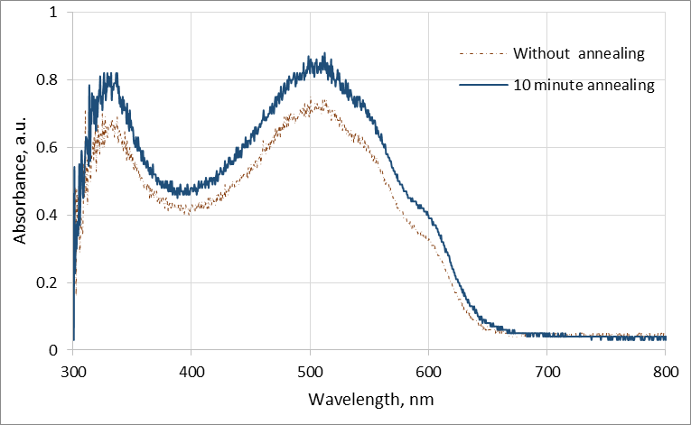
Figure 3. The Absorbance of Active Layers.
The higher the absorbance value the more light is absorbed by the active layer so that more current can be generated by solar cells. This is in accordance with the IPCE measurement results where active layer with 10 minutes annealing give better IPCE value than without annealing. Figure 4 shows that cell with 10 minute annealing has spectral response higher than without annealing, where the IPCE peak is 4.5% at wavelength of 560 nm. Whereas for cell without annealing has IPCE peak around 3% at 370 nm. There is a shift of mountain like IPCE curve from shorter wavelength to longer wavelength with higher IPCE, which is affected by 10 minute annealing of the active layer. The curve shift to higher wavelength with higher efficiency is related to the more orderly structure of the P3HT chain due to heat treatment as previously discussed.
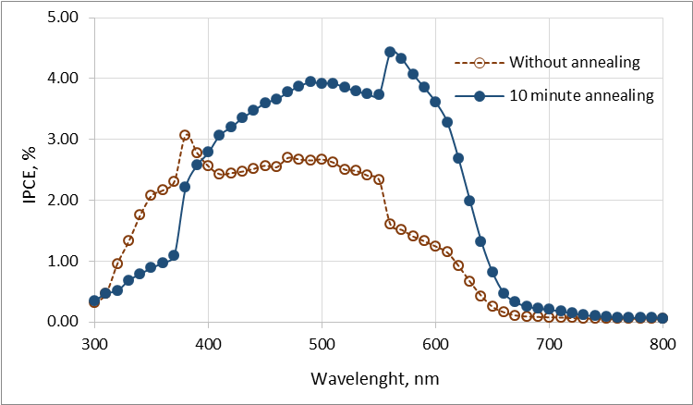
Figure 4. The IPCE Measurement Results.
Figure 5 shows J-V characteristics for inverted polymer solar cells with and without thermal annealing process, where the extracted device parameters are summarized in Table 1. From the figure and the table, it can be seen that cell with 10-minute annealing has better I-V characteristics than without annealing. It has open-circuit voltage (V_{OC}), short-circuit current density (J_{SC}), fill factor (FF), and PCE as high as 0.21 volt, 1.33 mA/cm², 43.1%, and 0.22% respectively. On the other hand for cell without thermal annealing has V_{OC} = 0.12 V, J_{SC} = 1.32 mA/cm², FF = 33.7%, and PCE = 0.11%.
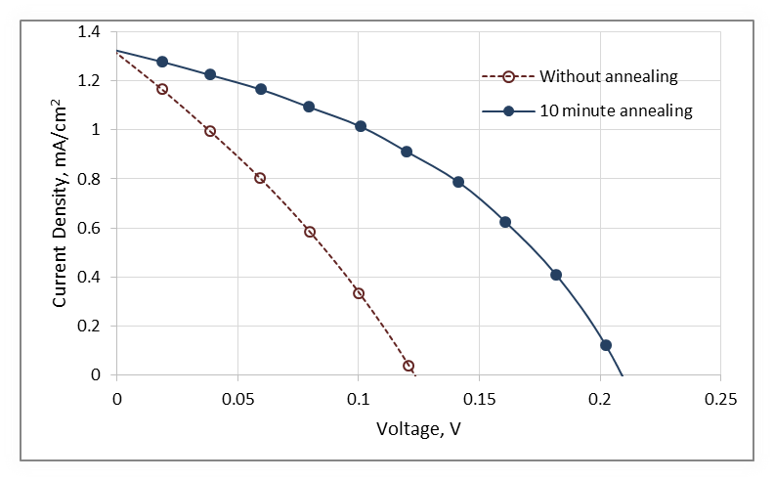
Figure 5. The I-V Characteristics.
As discussed above that by annealing, PH3T:PCBM blends active layer has better organized structure of morphology. The P3HT chains can organize and self-assemble into a more regular, crystalline state, resulting in higher charge mobility. PCBM acceptor material will also diffuse and aggregate to form larger domains. Therefore, annealing process can maximize donor - acceptor interfacial area and lead to higher degree of crystallinity so that the PSC performance is improved [21]. For comparison, Li et. al used P3HT:PCBM blend with the same ratio as the active layer but with conventional PSC structure, they obtained that 10 minute annealing at 110 ℃ can increase the PCE of the cell as high as 24% (3.52% without annealing becomes to 4.37% with annealing). The increased PCE on the side is caused by the the formation of self-organized ordered structure in the P3HT/PCBM blend system as discussed earlier, the surface of the active layer also becomes smoother on annealing [9].
Table 1.
The Electrical Characteristics of Inverted Polymer Solar Cells by Measuring Under 500W/M² and AM 1.5 Direct Filter at Room Temperature.
Parameters | Without annealing | 10 minute  annealing
PCE (%)  J_{SC} (mA/cm²)  V_{OC} (Volt)  FF (%) | 0.11  1.32  0.12  33.7 | 0.22  1.33  0.21  43.1
In general, the electrical characteristics generated from the inverted PSC i.e. V_{OC}, J_{SC}, and PCE are very low compared to the results conducted by the other researchers with the same inverted PSC structure, but different in ZnO interlayer formation [14], [15]. We use a short route by dissolving ZnO nanoparticles powder in the chloroform-methanol solvent blend rather than sol-gel route, whereas they used sol-gel route in the formation of ZnO interlayer and they got dense and uniform ZnO layer surface with the roughness, rms (root mean square) less than 3 nm. They had achieved PCE, V_{OC}, and J_{SC} more than 3%, 0.6 V, and 7 mA/cm² respectively. The low electrical characteristics are ascribed by the roughness of the resulting ZnO interlayer. Figure 6 shows SEM image of ZnO interlayer surface which was formed by dissolving ZnO nanoparticles powder in chloroform-methanol solvent blend. It can be seen that the ZnO layer surface is not dense and non-uniform. The layer has rough surface, which comprises of nanoparticle agglomerates and some cavities or voids. We do not measure the ZnO layer roughness, but according the figure it is estimated that the voids size could be in micrometer scales.
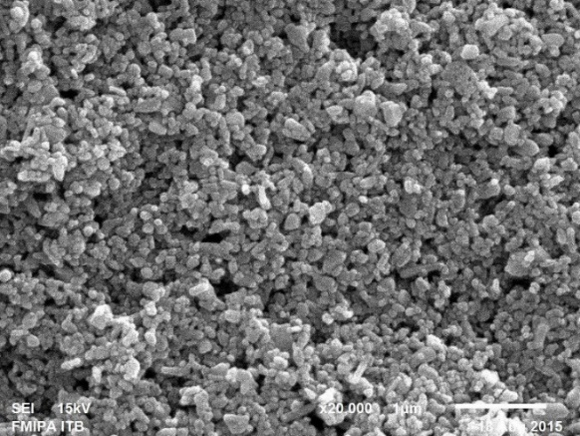
Figure 6. SEM image of ZnO interlayer surface.
Very rough ZnO interlayer surface will cause the formation of voids or cavities between the ZnO interlayer with the active layer, the more rough surface the more cavities or voids are formed. The cavities or voids are the recombination centrals of free charges into excitons, so the more cavities or voids formed the fewer free charges generated [15]. The cavities or voids also cause the quality of the contact between the active layer and ZnO layer become low, where series resistance become high and shunt or parallel resistance become low, which in turn will cause a high leakage current. These will result in the low FF and J_{SC} [14]. According to the research in [22], the V_{OC} and its light-intensity dependence are strongly affected by recombination of holes with trapped electrons. The higher amount of traps (in this case is cavities or voids) provides the lower the resulted V_{OC}. Moreover, by the existence of the voids or cavities in ZnO interlayer, ZnO as an electron transport seems not functioning because there is direct contact between ITO and P3HT:PCBM interfaces through the cavities. Based on a study carried out in [23], an organic solar cell with inverted structure without ZnO interlayer as electron transport gives low cell performance with V_{OC} and PCE as low as 0.13 V and 0.19% respectively.
Besides ZnO surface roughness with its voids and cavities as mentioned above, the morphology of active layer in organic bulk hetero junction might be playing a very important role in the low performance of the cells. The morphology determines domain size of donor and acceptor, intimately mixed phase separation of donor and acceptor, and percolated pathway towards respective anode and cathode for charge collection. There are several methods to control this morphology, among of them are polymer and fullerene ratios, selection of solvents, thermal annealing, and introducing additives [24]. In this study, we use heat treatment to control the morphology. Besides the annealing time of active layer as the variable process, we use another heat treatments in inverted cell fabrication that include PEDOT:PSS layer annealing at 100 ℃ for 20 minutes and cell lamination process at 100 ℃ for 10 minutes. Presumably, the temperature and duration of heat treatment chosen is not enough to obtain good morphology for producing high-performance solar cells. Therefore, it is required a selection of correct temperature and time for heat treatment processes of the cells. Because with excessive temperature and longer heat treatment, larger size phase separations (domains) will be further formed, the P3HT will flow and the PCBM will form aggregates, which resulted in a large extent of phase separation and the disruption of bi-continuous phases [20]. Besides this can lead to decreasing the donor-acceptor interfacial area, the domains size with more than exciton diffusion length (5-10 nm) also can cause the recombination of generated free charges. These will result in lower cells performance [20], [21].

Conclusion
Inverted polymer solar cells based on P3HT: PCBM blends as an active layer with the structure of ITO/ZnO/P3HT: PCBM/PEDOT:PSS/Ag has been fabricated. The cell with annealing process of the active layer at 110 ℃ for 10 minutes resulted in higher cell performance than without annealing, with an open-circuit voltage of 0.20 volt, a short-circuit current density of 1.33 mA/cm², a fill factor of 43.1%, and a power conversion efficiency of 0.22%. The low cell performance was caused by the very rough surface of ZnO interlayer. Therefore, further study will be focused on surface evenness and thickness of the ZnO as an interlayer to obtain higher cell performance.

Acknowledgement
This work was supported by Research Center for Electronics and Telecommunication Indonesian Institute of Sciences (PPET LIPI) through DIPA Tematik Program 2015.

Reference
- C. J. Brabec, “Organic photovoltaics: technology and market”, Sol. Energy Mater. Sol. Cells, vol. 83, pp. 273-292, 2004.
- C. Deibel, V. Dyakonov, “Polymer–fullerene bulk heterojunction solar cells”, Rep. Prog. Phys., vol. 73, pp. 096401, 2010.
- F. C. Krebs, M. Jørgensena, K. Norrman, O. Hagemann, J. Alstrupa, T. D. Nielsena, J. Fyenbo, K. Larsen, and J. Kristensen, “A complete process for production of flexible large area polymer solar cells entirely using screen printing-First public demonstration”, Sol. Energy Mater. Sol. Cells, vol. 93, pp. 422-44, 2009.
- N. Espinosa, R. G. Valverde, A. Urbina, F. C. Krebs, “A life cycle analysis of polymer solar cell modules prepared using roll-to-roll methods under ambient conditions,” Sol. Energy Mater. Sol. Cells, vol. 95, pp. 1293-1302, 2011.
- G. Yu, J. Gao, J. C. Hummelen, F. Wudl, and A. J. Heeger, “Polymer photovoltaic cells: enhanced efficiencies via a network of internal donor-acceptor heterojunctions,” Science, vol. 270, iss. 5243, pp. 1789-1791, 1995.
- Y. He, Y. F. Li, “Fullerene derivative acceptors for high performance polymer solar cells,” Phys. Chem. Chem. Phys., vol. 13 pp. 1970-1983, 2011.
- J. Hou, X. Guo, “Active layer materials for organic solar cells,” in Organic Solar Cells, Green Energy and Technology, W. C. H. Choy, Ed., London: Springer-Verlag, 2013, p. 17.
- M. M. Wienk, J. M. Kroon, W. J. H. Verhees, J. Knol, J. C. Hummelen, P. A. van Hal, R. A. J. Janssen, “Efficient methano [70] fullerene/MDMO-PPV bulk heterojunction photovoltaic cells,” Angew. Chem. Int. Ed., pp. 3371-3375, 2003.
- G. Li, V. Shrotriya, J. Huang, Y. Yao, Tommoriarty, K. Emery, Y. Yang, “High-efficiency solution processable polymer photovoltaic cells by self-organization of polymer blends,” Nat. Mater., pp. 864-868, 2005.
- H. Zhou, L. Yang, A. C. Stuart, S. C. Price, S. Liu, W. You, “Development of fluorinated benzothiadiazole as a structural unit for a polymer solar cell of 7% efficiency,” Angew. Chem. Int. Ed., pp. 2995-2998, 2011.
- M. Jørgensen, K. Norrman, F.C. Krebs, “Stability/degradation of polymer solar cells,” Sol. Energy Mater. Sol. Cells, pp. 686-714, 2008.
- S. J. Lee, B. S. Kim, J. Y. Kim, A. R. bin Mohd Yusoff, J. Jang, “Stable organic photovoltaic with PEDOT:PSS and MoOX mixture anode interfacial layer without encapsulation,” Org. Electron., pp. 140-146, 2015.
- K. W. Wong, H. L. Yip, Y. Luo, K. Y. Wong, W. M. Lau, K. H. Low, H. F. Chow, Z. Q. Gao, W. L. Yeung, C.C. Chang, “Blocking reactions between indium-tin oxide and poly 3,4-ethylene dioxythiophene:poly.styrene sulphonate with a self-assembly monolayer,” Appl. Phys. Lett., pp. 2788-2790, 2002.
- Z. Liang, Q. Zhang, O. Wiranwetchayan, J. Xi, Z. Yang, K. Park, C. Li, G. Cao, “Effects of the morphology of a ZnO buffer layer on the photovoltaic performance of inverted polymer solar cells,” Adv. Funct. Mater., pp. 2194-2201, 2012.
- Z. Ma, Z. Tang, E. Wang, M.R. Andersson, O. Inganäs, F. Zhang, “Influences of surface roughness of ZnO electron transport layer on the photovoltaic performance of organic inverted solar cells,” J. Phys. Chem. C, pp. 24462-24468, 2012.
- P. Li, T. Jiu, G. Tang, G. Wang, J. Li, X. Li, J. Fang, “Solvents induced ZnO nanoparticles aggregation associated with their interfacial effect on organic solar cells,” ACS Appl. Mater. Interfaces, pp. 18172-18179, 2014.
- D. Chirvase, J. Parisi, J. C. Hummelen, V. Dyakonov, “Influence of nanomorphology on the photovoltaic action of polymer-fullerene composites,” Nanotechnology, pp. 1317-1323, 2004.
- V. Shrotriya, J. Ouyang, R. J. Tseng, G. Li, Y. Yang, “Absorption spectra modification in poly(3-hexylthiophene): methanofullerene blend thin films,” Chem. Phys. Lett., pp. 138-143, 2005.
- R. Kroon, M. Lenes, J. C. Hummelen, P. W. M. Blom, B. de Boer, “Small bandgap polymers for organic solar cells (polymer material development in the last 5 years),” Polym. Rev., pp. 531-582, 2008.
- Y. C. Huang, Y. C. Liao, S. S. Li, M. C. Wu, C. W. Chen, W. F. Su, “Study of the effect of annealing process on the performance of P3HT/PCBM photovoltaic devices using scanning-probe microscopy,” Sol. Energy Mater. Sol. Cells, pp. 888-892, 2009.
- J. T. Chen, C. S. Hsu, “Conjugated polymer nanostructures for organic solar cell applications,” Polym. Chem., pp. 2707-2722, 2011.
- M. M. Mandoc, F. B. Kooistra, J. C. Hummelen, B. de Boer, P. W. M. Blom, “Effect of traps on the performance of bulk heterojunction organic solar cells,” Appl. Phys. Lett., pp. 263505, 2007.
- Y. J. Noh, S. I. Na, S. S. Kim, “Inverted polymer solar cells including ZnO electron transport layer fabricated by facile spray pyrolysis”, Sol. Energy Mater. Sol. Cells, pp. 139-144, 2013.
- G. Li, R. Zhu, Y. Yang, “Polymer solar cells,” Nat. Photonics, pp. 153-161, 2012.

